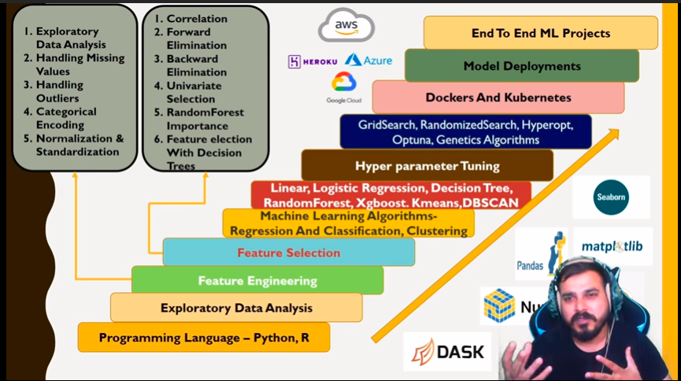
Regression
https://www.analyticsvidhya.com/blog/2015/08/comprehensive-guide-regression/

Simple Linear Regression
https://www.youtube.com/watch?v=1-OGRohmH2s
https://www.kdnuggets.com/2020/05/5-concepts-gradient-descent-cost-function.html

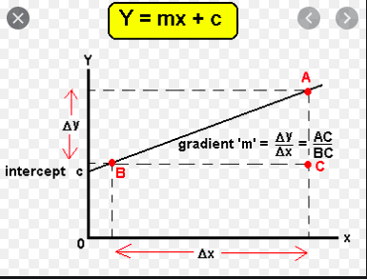

Y-hat is point in linear line. m=total no. Of dataset
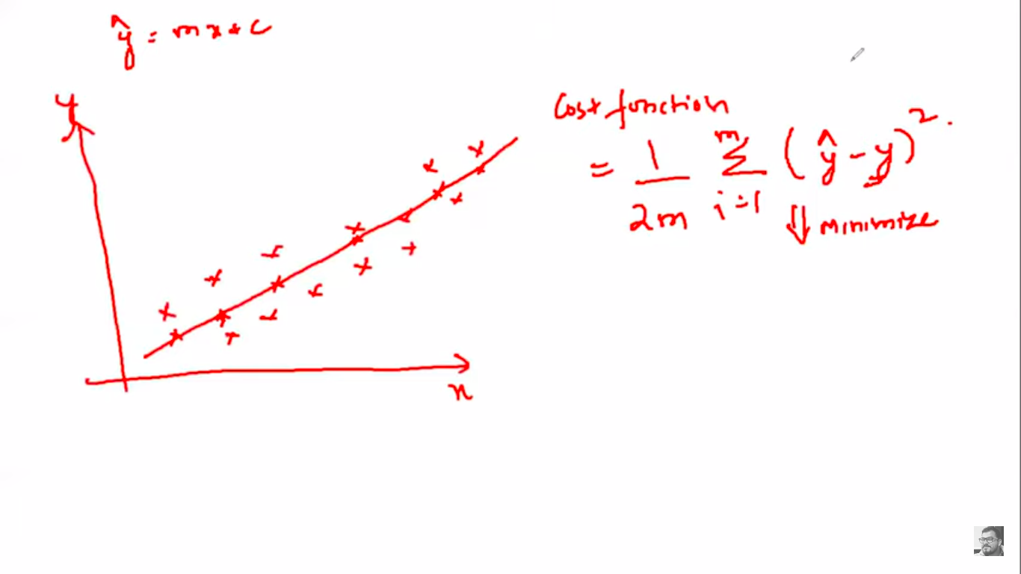

Cost function is calculated by changing the scope(m). Here we have considered interceptor(c) as 0.
J(m) cost function & m is slope in second figure. Global minimum is considered as optimal slope for regression line(1 in this case)

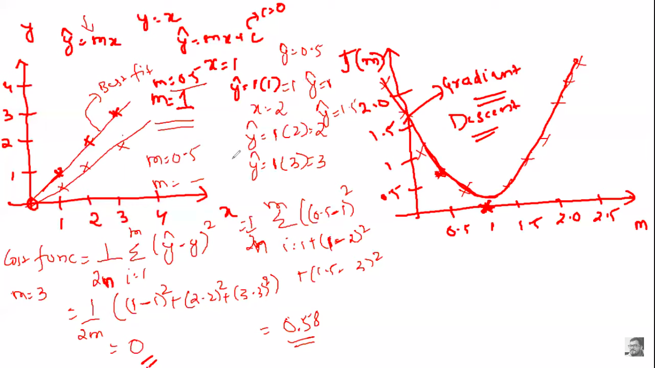
Learning rate should be selected as small value else it will form zip-zap curve with high variance which is hard to determine global minima. On drawing straight line, if right part of line pointing downwards, then its -ve slope. If right part of line pointing upwards then its +ve slope
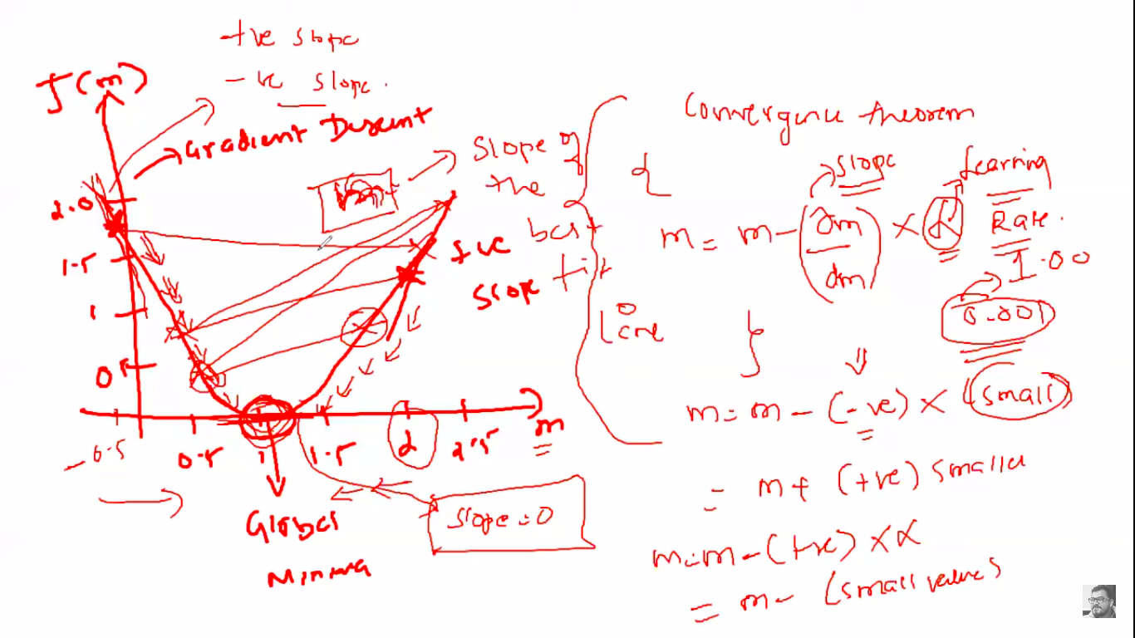
m is interceptor(I) (or) slope based on the constant value we choose. If I chosen interceptor as 0, then m is slope
Gradient descent mathematical calculation: https://www.mygreatlearning.com/blog/gradient-descent
Dotted straight line is called as tangent line. Slope of 2 points or 1 point using Tangent line is explained in https://www.mathsisfun.com/calculus/derivatives-introduction.html. It follows 1st order derivative. Refer Common --> Derivative --> First Order Derivatives

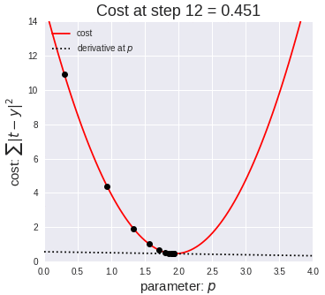

Multiple Linear Regression
Coefficient of Multiple Determination
The coefficient of multiple determination (R2) measures the proportion of variation in the dependent variable that can be predicted from the set of independent variables in a multiple regression equation. When the regression equation fits the data well, R2 will be large (i.e., close to 1); and vice versa.
The coefficient of multiple correlation can be defined in terms of sums of squares:
SSR = Σ ( ŷ - y )2
SSTO = Σ ( y - y )2
R2 = SSR / SSTO
where SSR is the sum of squares due to regression, SSTO is the total sum of squares, ŷ is the predicted value of the dependent variable, y is the dependent variable mean, and y is the dependent variable raw score.
https://stattrek.com/statistics/dictionary.aspx?definition=coefficient-of-multiple-determination
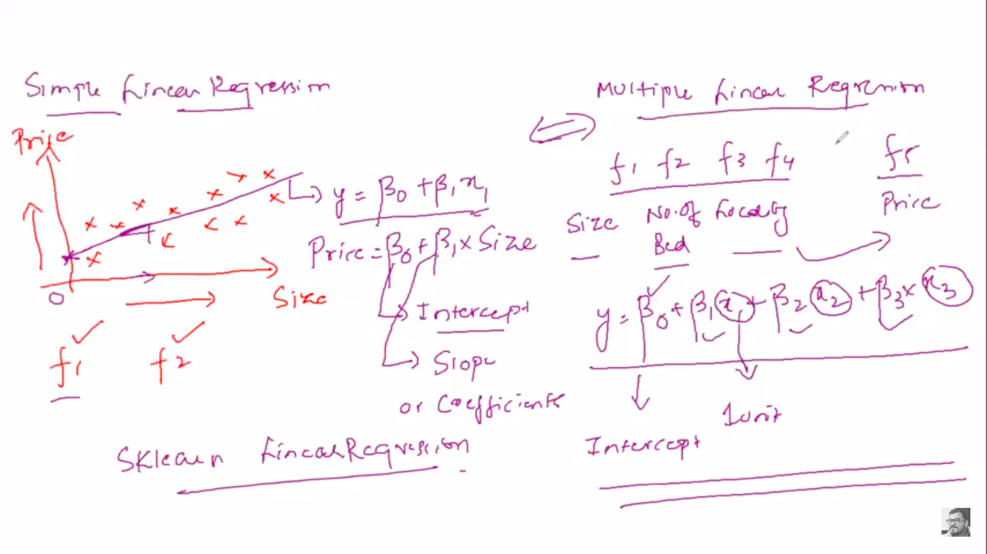
Python-coefficient-of-determination : https://www.geeksforgeeks.org/python-coefficient-of-determination-r2-score/
y-cap = Predicted value & y-dash is mean of y
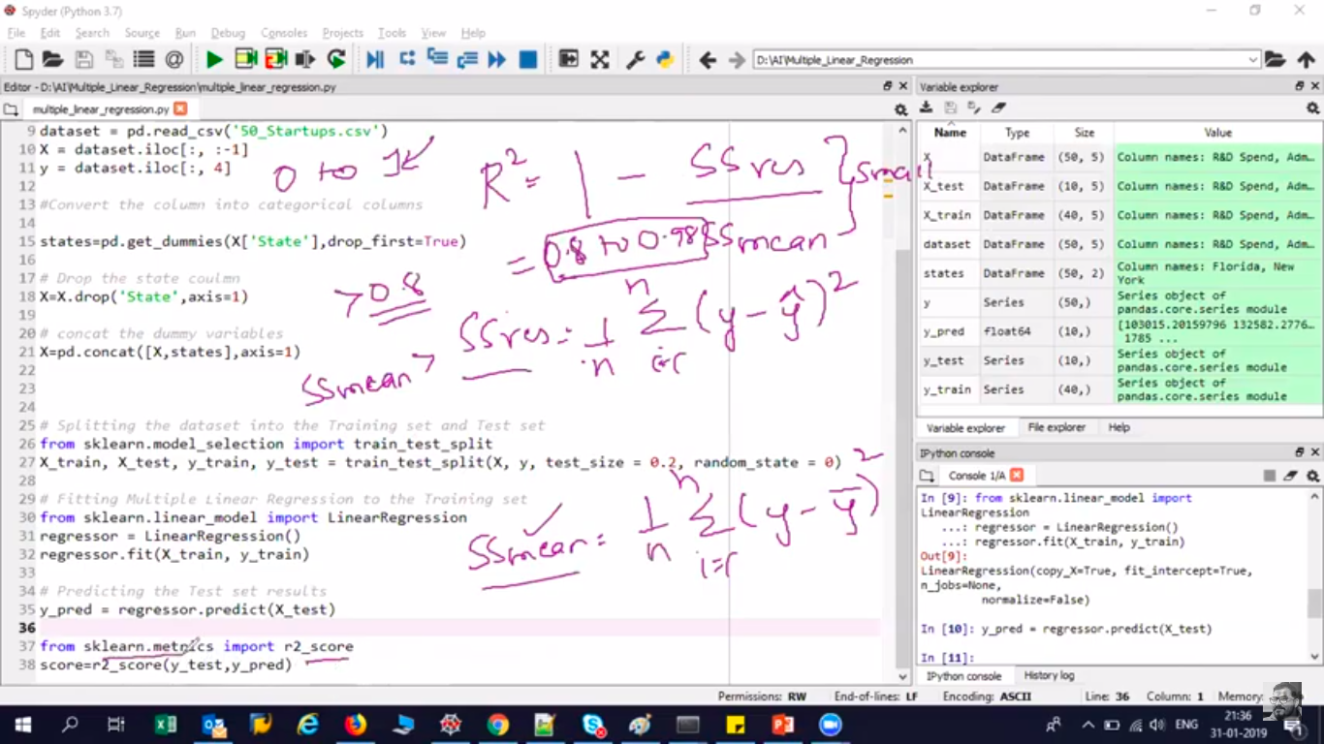

Polynomial Regression
https://medium.com/analytics-vidhya/understanding-polynomial-regression-5ac25b970e18

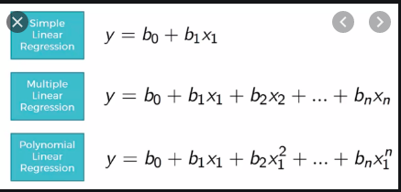

poly_reg=PolynomialFeatures(degree=4)
degree(d)=1 represents y=b0+b1x1+b2x1^2. d=3 then upto b3x1^3
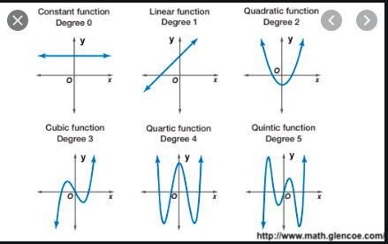

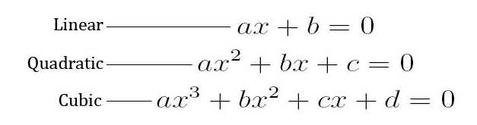

Support Vector Regression
https://medium.com/coinmonks/support-vector-regression-or-svr-8eb3acf6d0ff
http://www.saedsayad.com/support_vector_machine_reg.htm
Equation at top right corner is solved in SVM in classification. In SVR, we care about the points within the boundaries. We will do summation of (i=1 to m) point outside the boundaries which should give us minimum acceptable error.
In simple regression we try to minimise the error rate. While in SVR we try to fit the error within a certain threshold. This might be a bit confusing but let me explain.
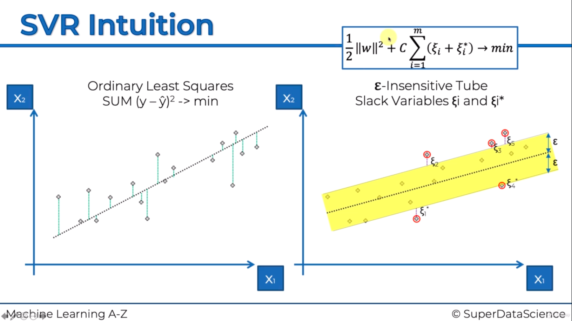
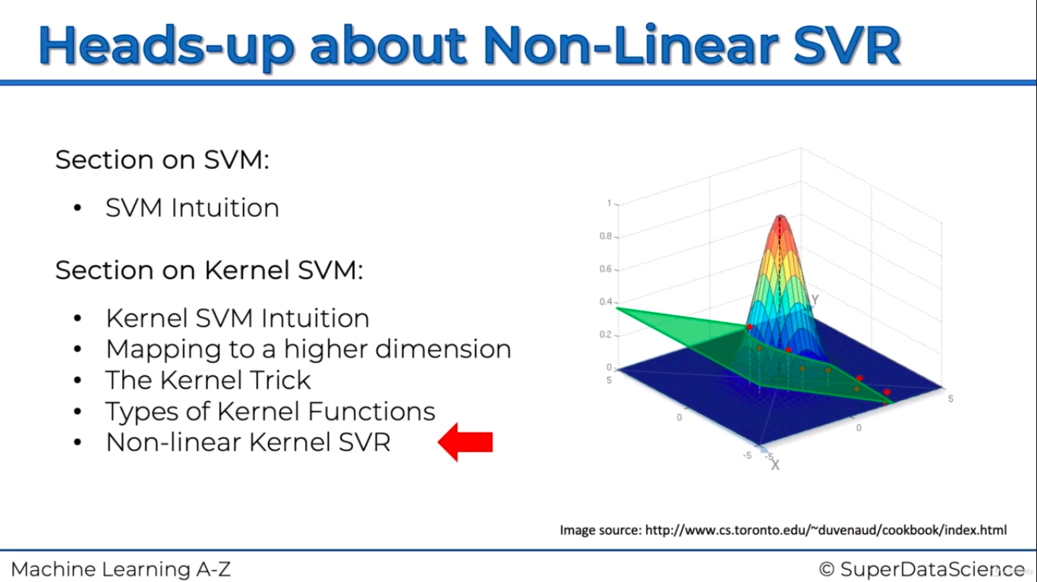

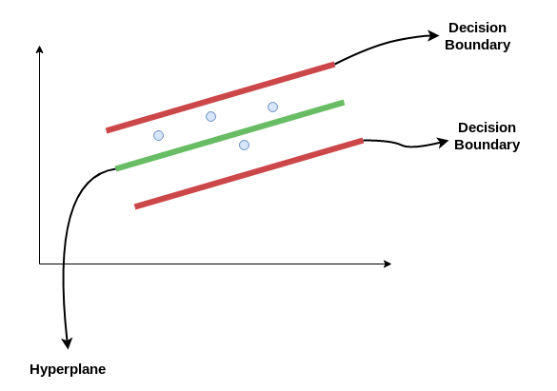

Ridge & Lasso Regression
Its available in ML_Common doc.

Classification

Logistic Regression
https://towardsdatascience.com/understanding-logistic-regression-9b02c2aec102
https://www.youtube.com/watch?v=L_xBe7MbPwk
https://www.youtube.com/watch?v=uFfsSgQgerw
https://developers.google.com/machine-learning/crash-course/logistic-regression/calculating-a-probability
http://faculty.cas.usf.edu/mbrannick/regression/Logistic.html
Logistic Regression is one of the basic and popular algorithm to solve a classification problem. It is named as ‘Logistic Regression’, because it’s underlying technique is quite the same as Linear Regression. The term “Logistic” is taken from the Logit function that is used in this method of classification.

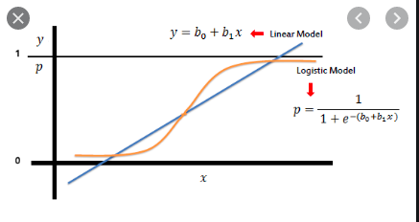

We shouldn’t use linear regression for binary classification for below mentioned reason
1. When lot of new data point comes, best fit(linear) line will be adjusted which will give error response
2. Most of the time we get output > 1 and < 0

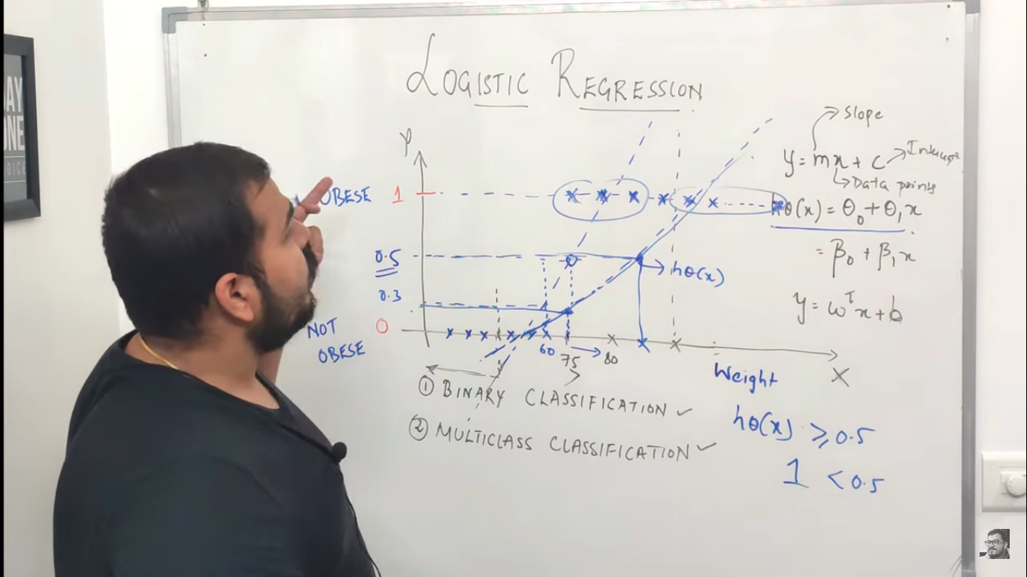

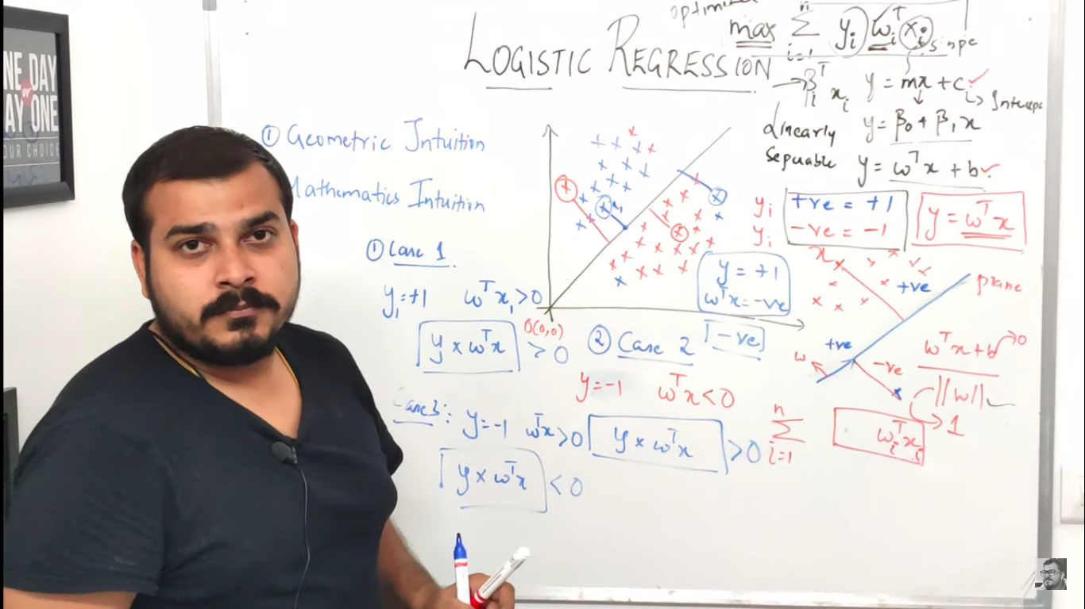
Max of summation of y(i)W(i)X(i) will be return max value(2) which will alter the best fit line which is incorrect. So we are applying sigmoid(1/1+e^-z) function to overcome this issue.
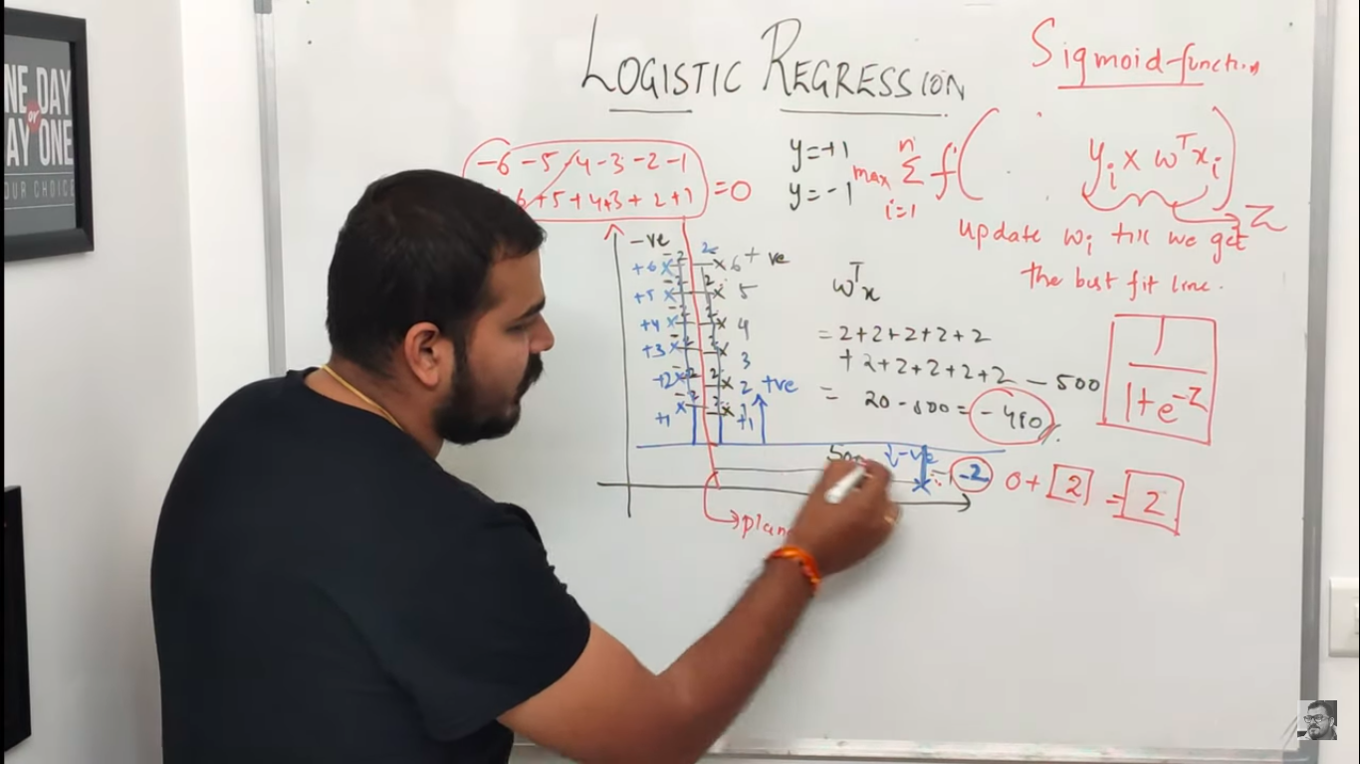
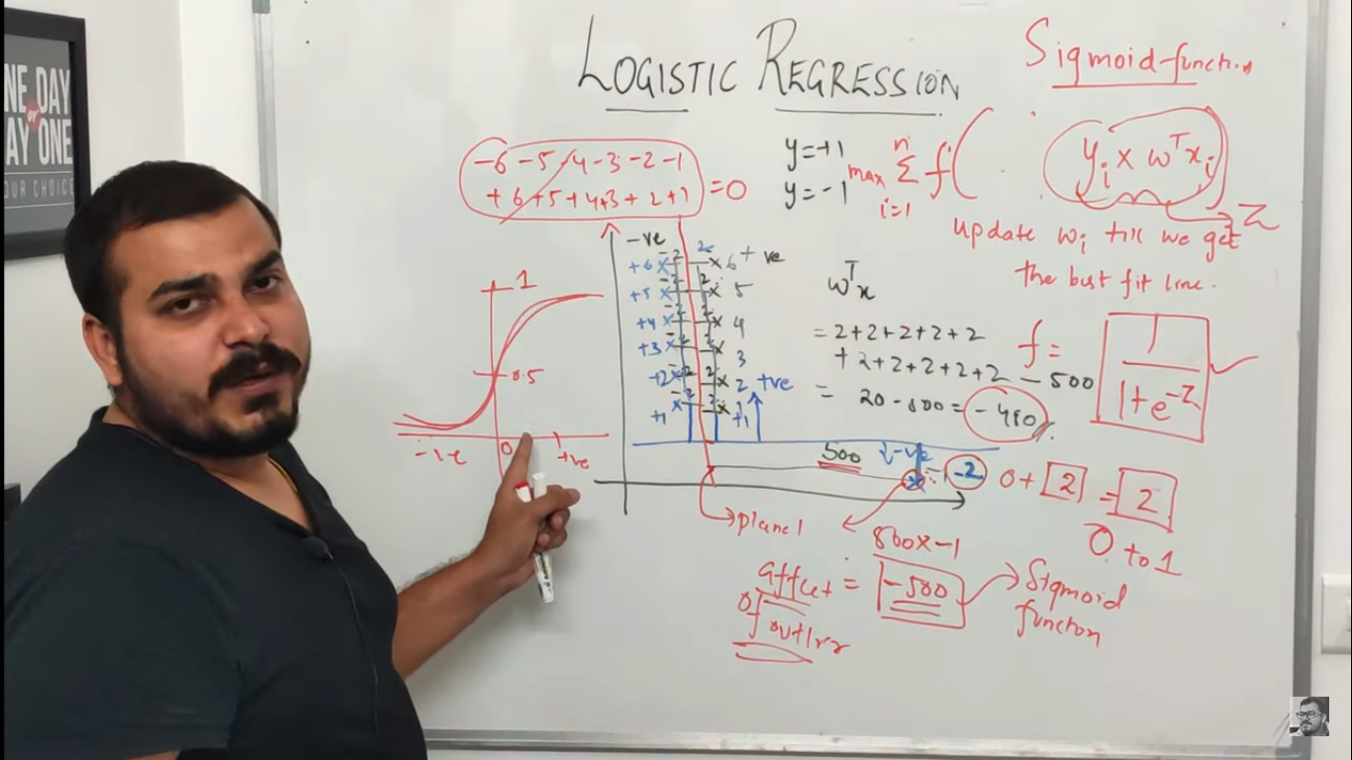

Support Vector Machine(SVM)
https://stackabuse.com/implementing-svm-and-kernel-svm-with-pythons-scikit-learn
https://towardsdatascience.com/https-medium-com-pupalerushikesh-svm-f4b42800e989
https://www.youtube.com/watch?v=H9yACitf-KM
https://www.youtube.com/watch?v=Js3GLb1xPhc
SVM supports both linear & non-linear(using Kernel SVM) data. Yellow line – Hyperplane & green line – Decision boundary (or) Margin.
The most optimal decision boundary is the one which has maximum margin from the nearest points of all the classes. The nearest points from the decision boundary that maximize the distance between the decision boundary and the points are called support vectors.
The hyperplane equation dividing the points (for classifying) can now easily be written as:
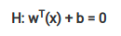

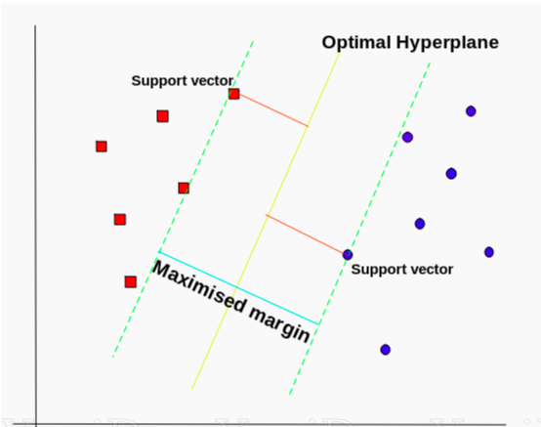

Distance between two decision boundaries(margin) should be maximum. In right top graph where a hyperplane is drawn vertically gives less distance than below graph(BG). BG is optimal. Data point(black circle) passes through margin is called support vector which helps us to detemine maximum marginal distance(supports SVM to draw decision (or) marginal boundary accordingly)
In below pic, we can draw many hyperplane & marginal line(boundary) but the optimal one is one that has maximum distance between the marginal line(boundary). The most optimal decision boundary is the one which has maximum margin from the nearest points of all the classes. D2 >> D1 in below pic, so we need to pick D2. Data point(can be one or many) through which marginal boundary passes is called Support Vectors.
If test data happens to fall between hyperplane & boundary, then it will be classified as specific category. If test data is between hyperplane & decision boundary (red(+ve)) class, then it belongs to +ve class(red) in below pic.
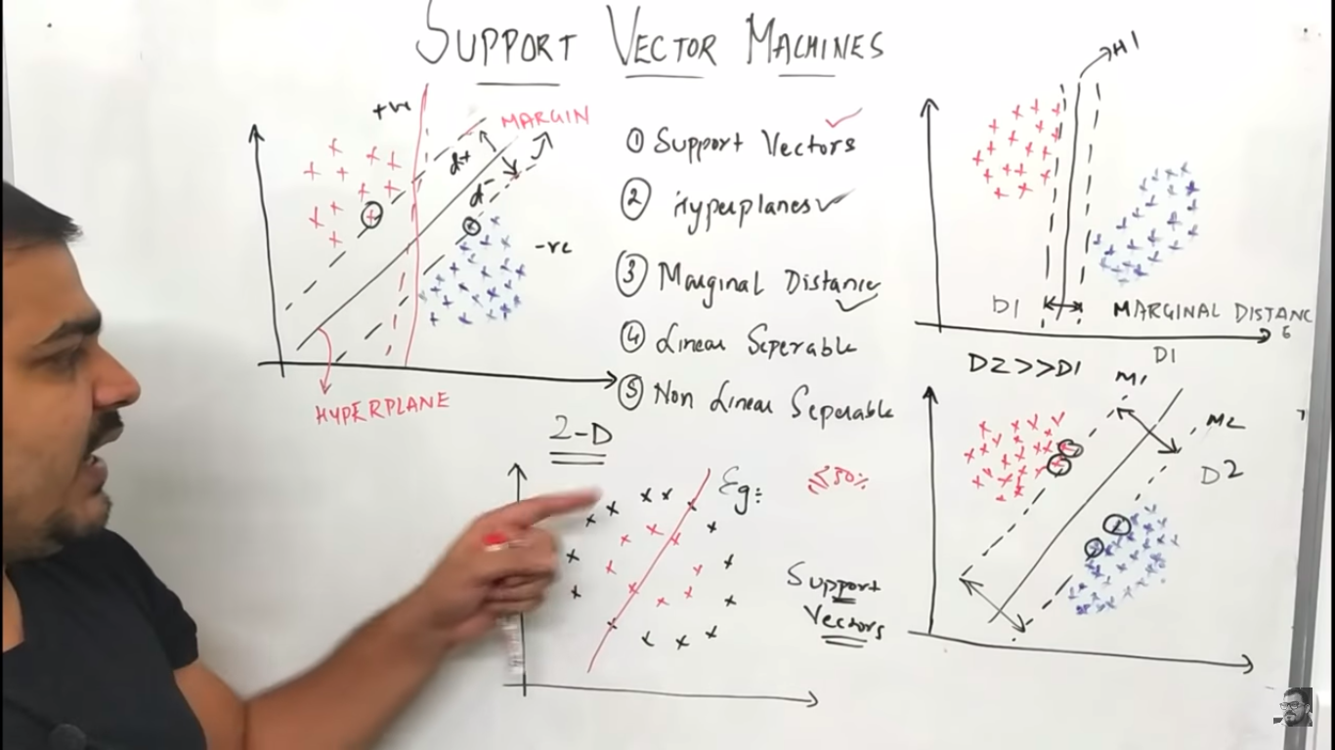
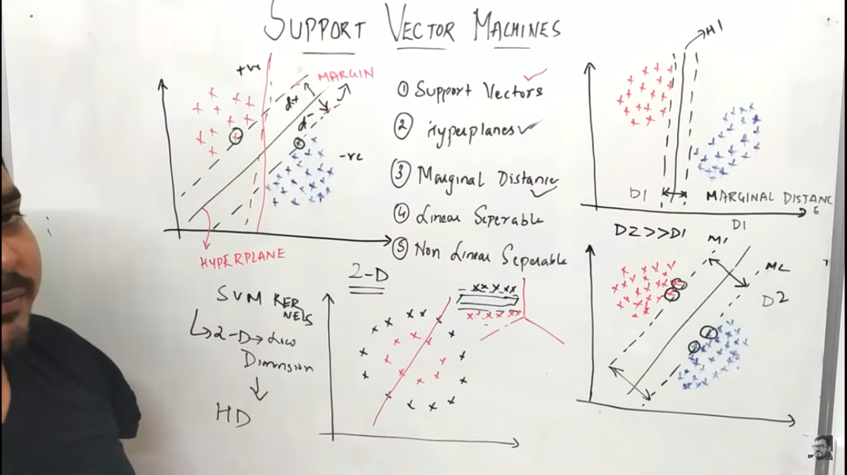
Kernel SVM will increase the dimension. 2D to higher dimension and apply hyperplane to easily separate the classification
Maths behind SVM
w^t = [slope, interceptor] = [-1 0]
W^t*x – W transpose x --> We are transposing to do matrix multiplication.

Bottom to the hyperplane will always be +ve since slope is -ve & x is also -ve. Top will be -ve since slope is -ve & x is also +ve.
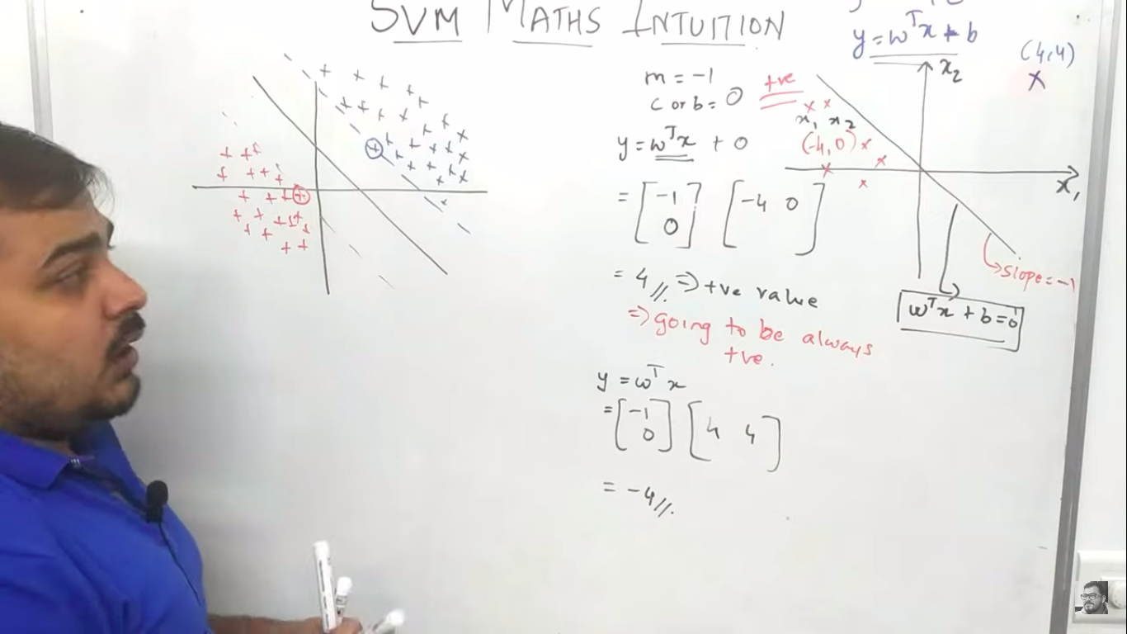
||w|| represents norm of the vector(w). Norm or Magnitude of u⃗ denoted ∥u⃗ ∥ is defined as the length or magnitude of the vector and can be calculated using the formula. Follows pythagoras theorem.
http://mathonline.wikidot.com/the-norm-of-a-vector

Below image is from https://towardsdatascience.com/support-vector-machine-formulation-and-derivation-b146ce89f28
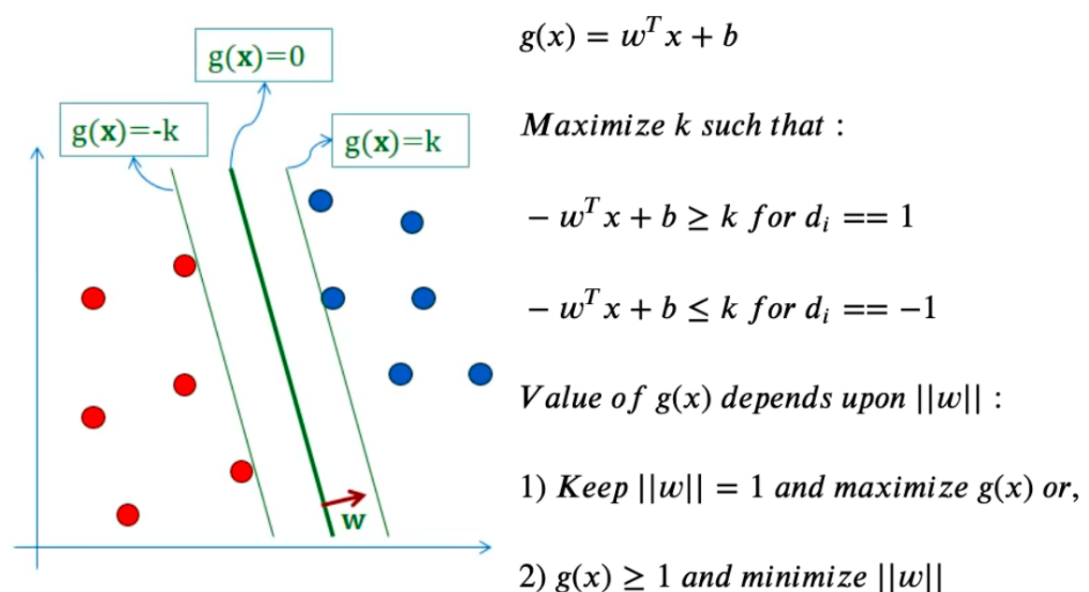
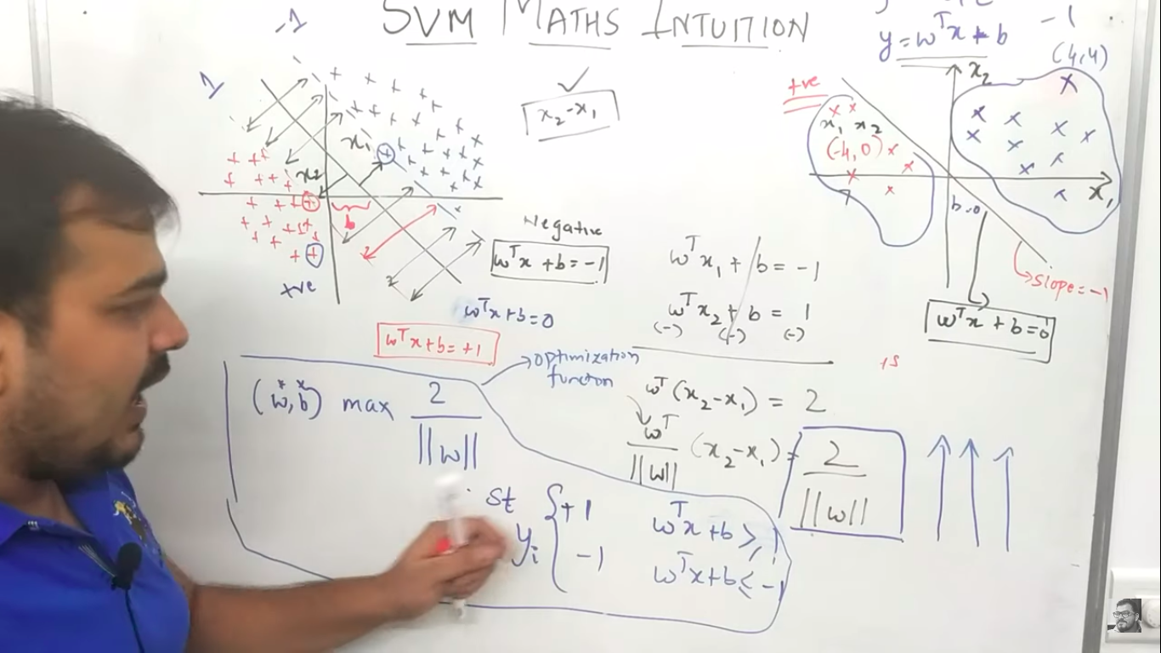
Value of the error is calculated as distance of the error point to its corresponding boundary line.
Regularization can be done by performing hyperparameterized tuning.
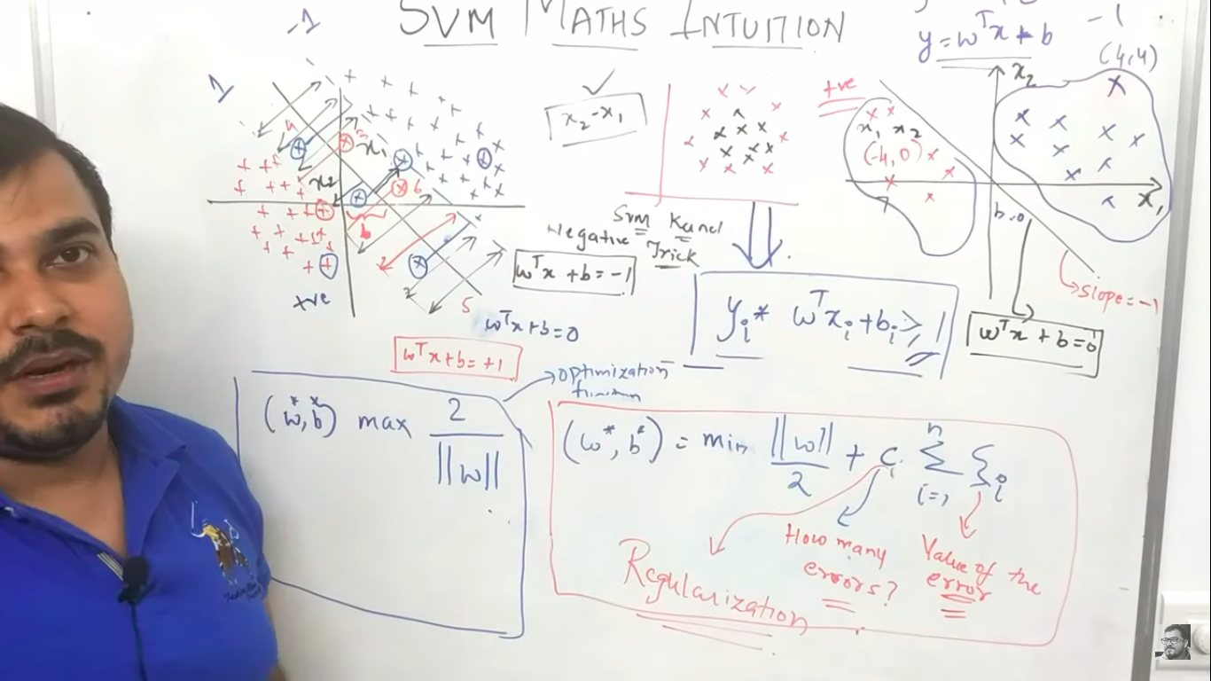

Kernel SVM
Kernel Tricks - https://www.youtube.com/watch?v=vMmG_7JcfIc
https://towardsdatascience.com/kernel-function-6f1d2be6091
Kernel SVM will increase the dimension. 2D to higher dimension and apply hyperplane to easily separate the classification
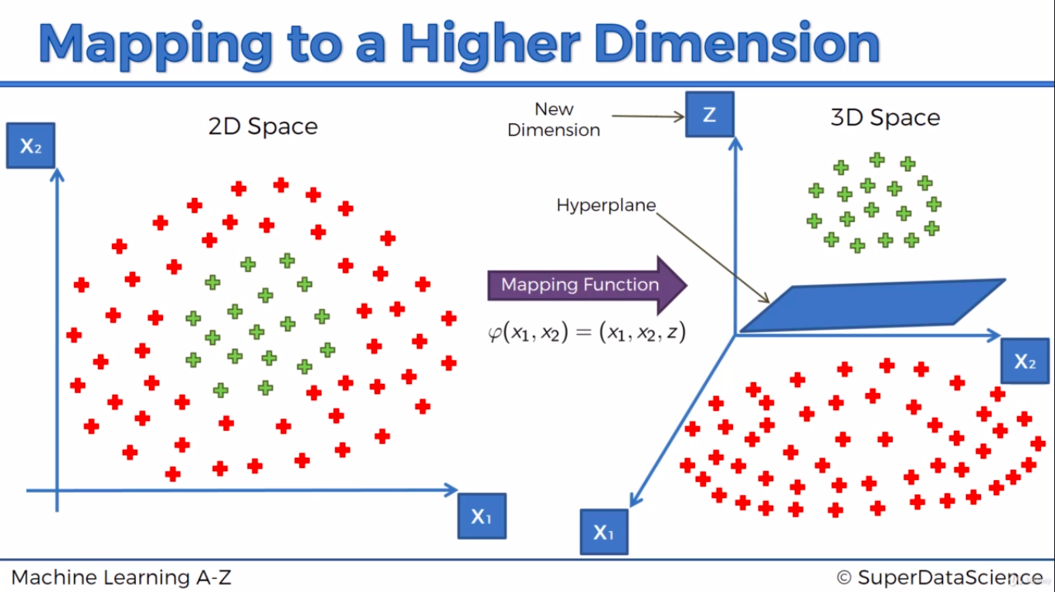
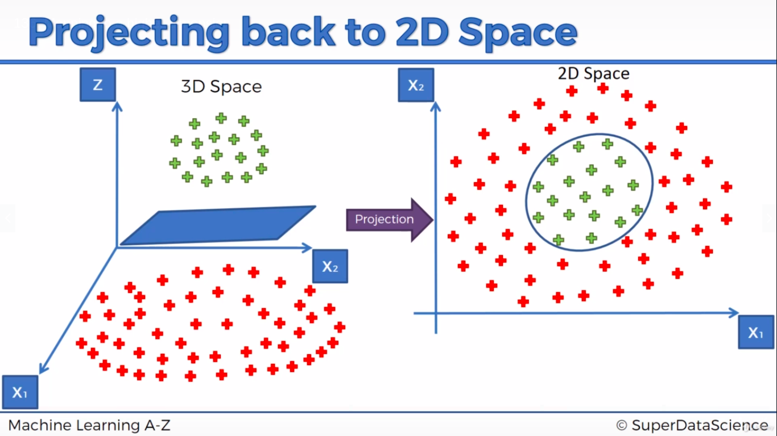

Red circle is landmark(l). Red plus is far from landmark, so large negative value will be there in exp power which will be evaluated to 0. Green plus is near, so exp power will be close to 0, ut evaluates to 1.
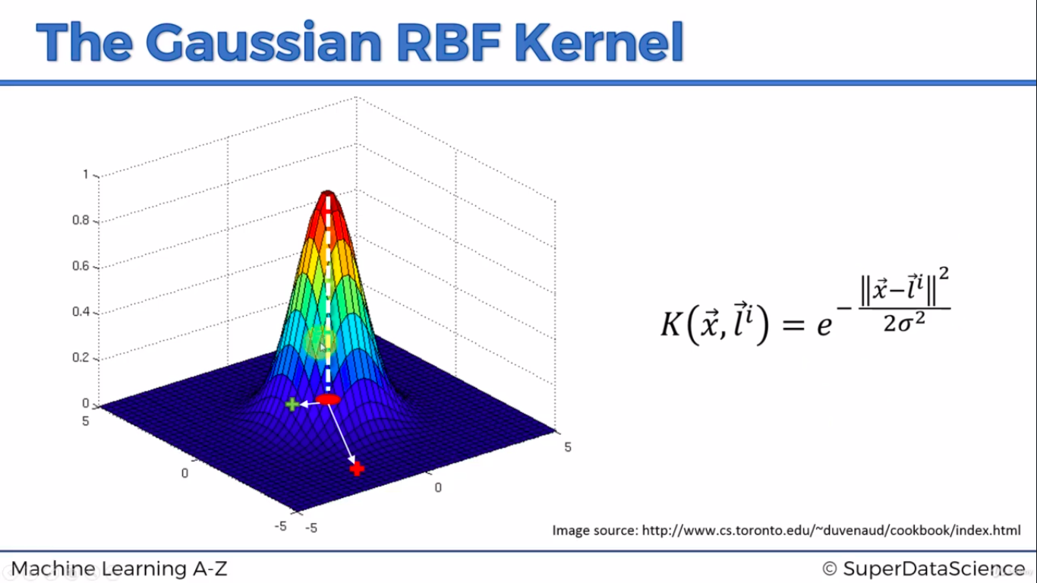
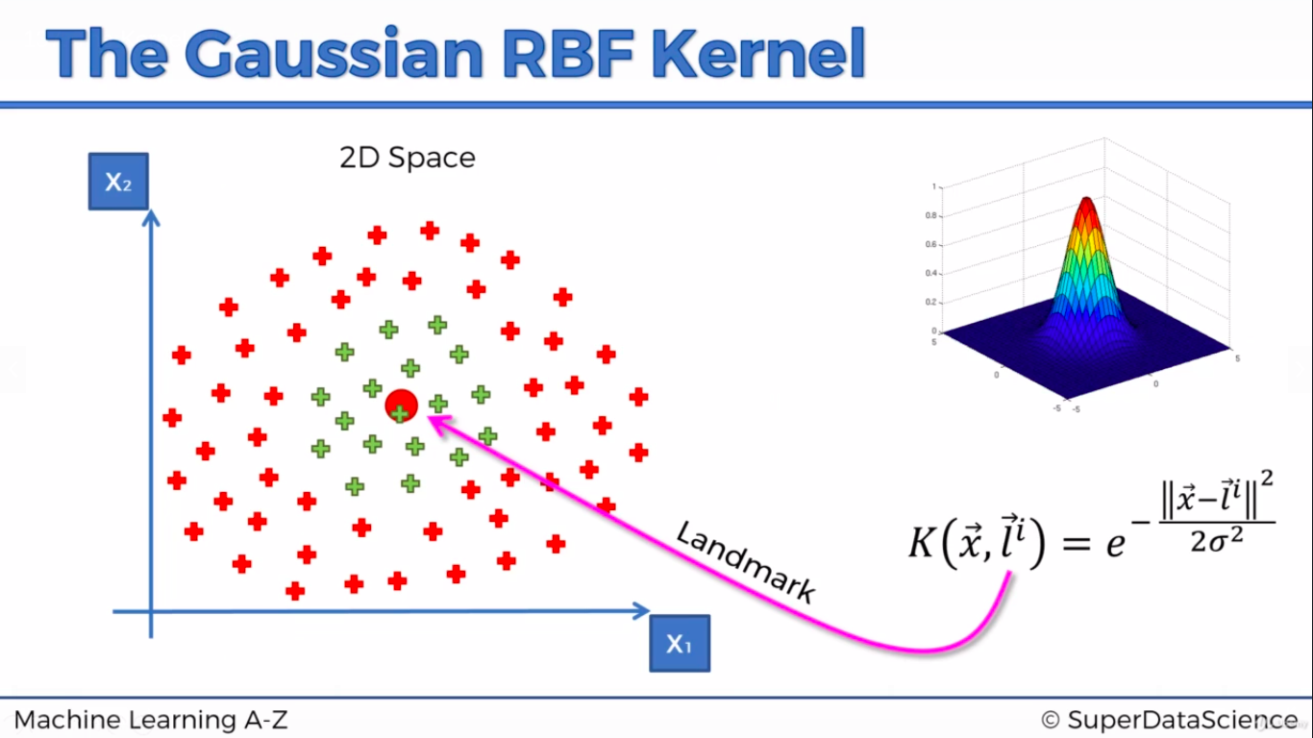

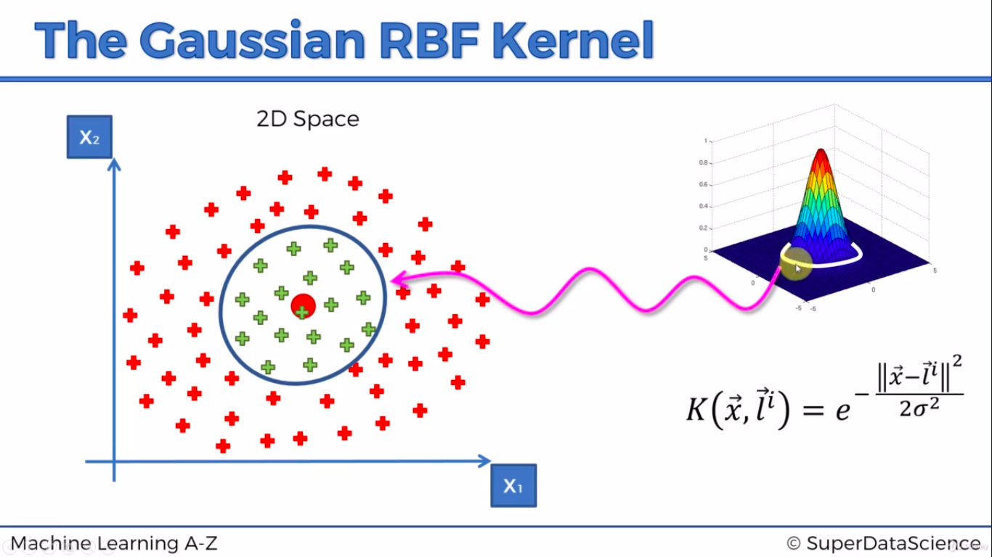
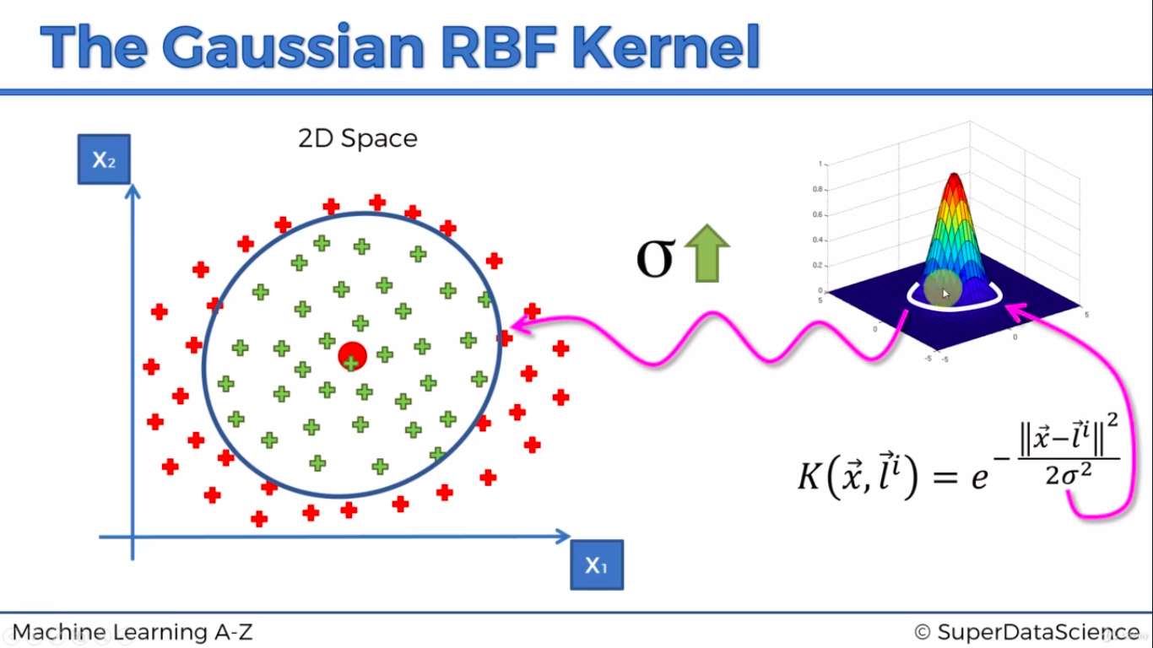
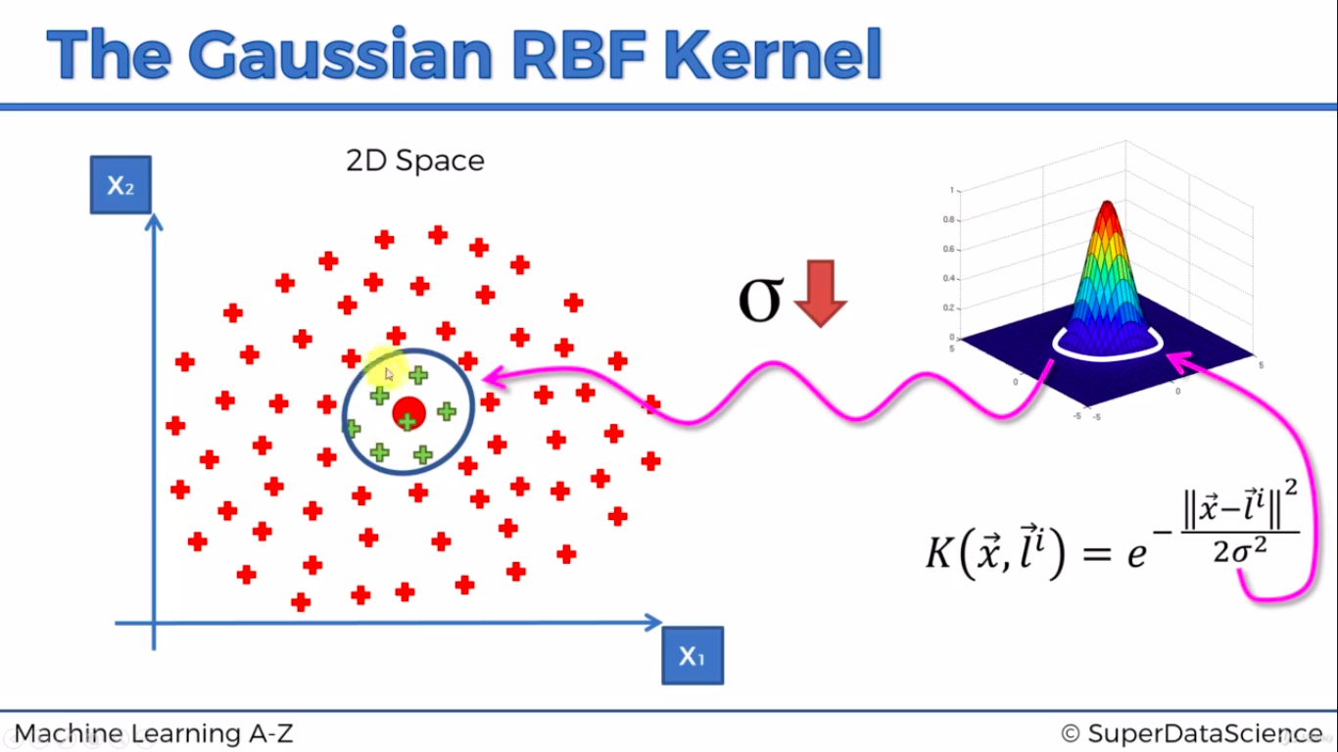

Naive Bayes
Check it in Scikit-Udemy.odt available in /home/vinoth/Learning/Python
argmax – max value of Yes/No is considered as prediction.

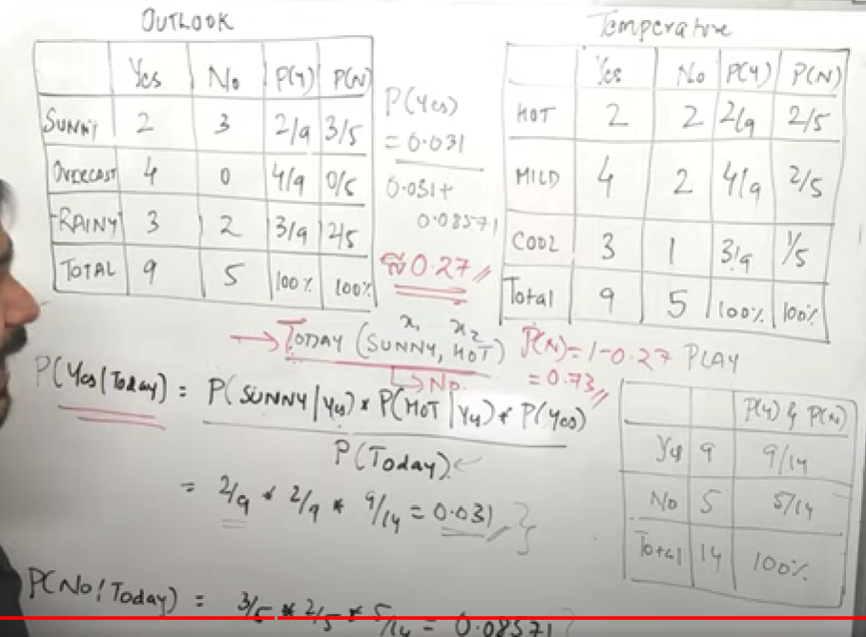
Calculate Probability of Yes & No given today & normalize it.

K-Nearest Neighbor(KNN)
Check it in Scikit-Udemy.odt available in /home/vinoth/Learning/Python

Decision Tree Classifier
https://www.youtube.com/watch?v=5O8HvA9pMew
https://www.youtube.com/watch?v=1IQOtJ4NI_0
https://medium.com/analytics-steps/understanding-the-gini-index-and-information-gain-in-decision-trees-ab4720518ba8
Tree algorithms: ID3, C4.5, C5.0 and CART
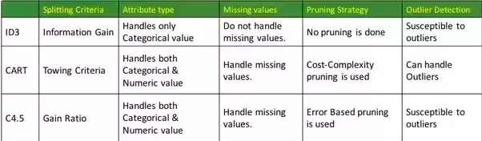
Features will be sorted first before performing split. Decision tree is created based on each feature and entropy is calculated. If feature has many records, time complexity will increase in decision tree. It applies for ensemble tree technique such as Random Forest & XGBoost algorithm.
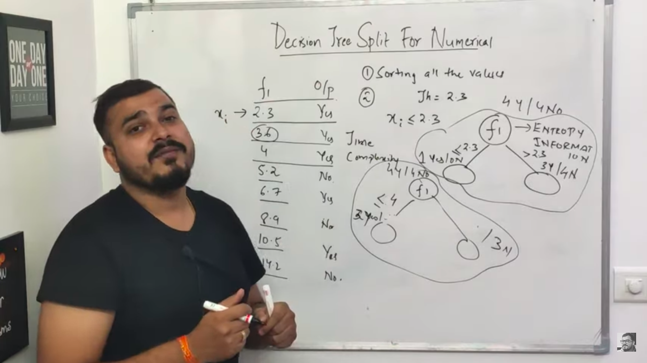

Entropy
0 means pure subset(either yes or No). 1 means completely impure subset(3 Yes & 3 No)
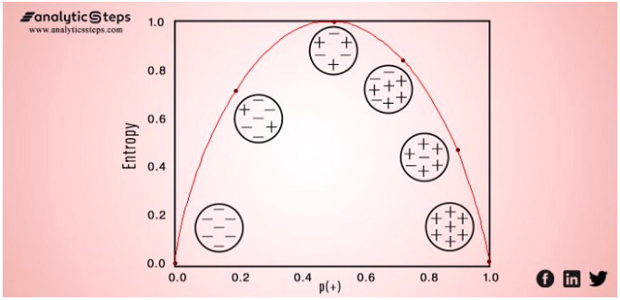
It is the measurement of the impurity or randomness in the data points. Entropy is calculated between 0 and 1. Entropy is the lowest (no disorder) at extremes (both end) and maximum (high disorder) in the middle of the graph
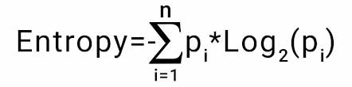
Below calculation is done for single node(f2). We need to calculate the summation of entropy till leaf node(last node)
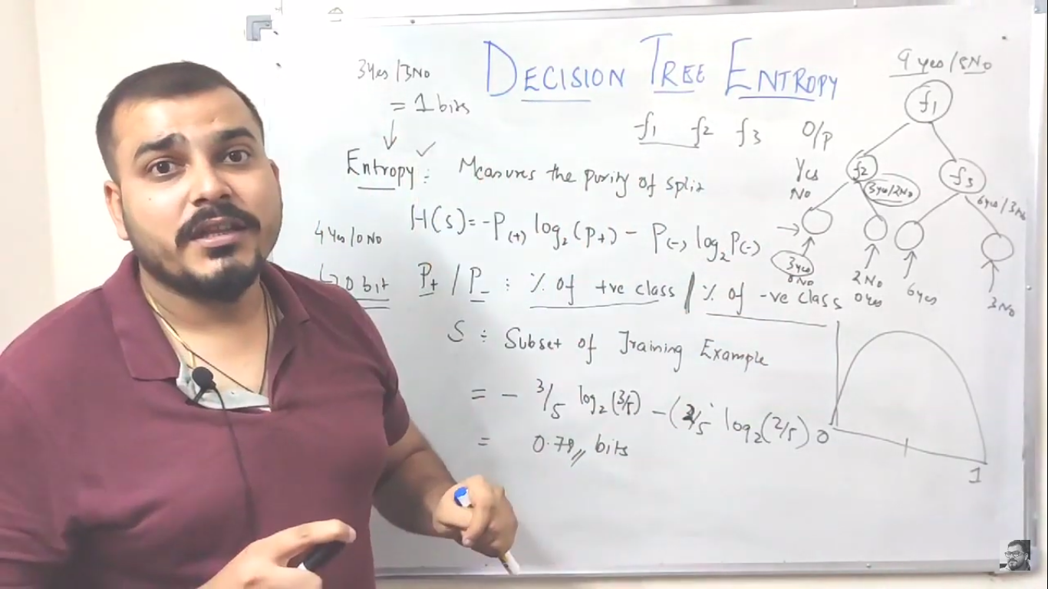

Information Gain
https://www.youtube.com/watch?v=FuTRucXB9rA&t=5s
Information gain(IG) is summation of all entropy till leaf node. Higher the IG, that tree will be best one. H(s)-Entropy of root node, |sv|-sum of Y/N in a node, |s|-no. Of Y/N in root node, H(Sv) – Entopy of node. Used in ID3 / C4.5 decision tree algorithm
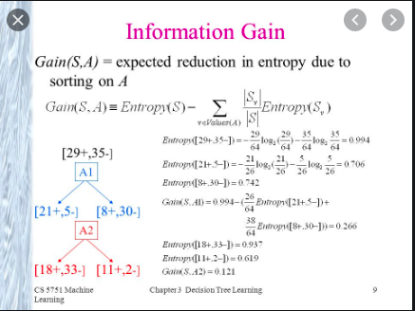


Gini Index
https://blog.quantinsti.com/gini-index/
https://github.com/rasbt/python-machine-learning-book/blob/master/faq/decision-tree-binary.md
Gini index(GI) or Gini impurity measures the degree or probability of a particular variable being wrongly classified when it is randomly chosen. 0 means pure, 1 means impure. It is used in CART decision tree algorithm. Computation of GI is very effective comparing to Entropy since it doesn't contain logarithmic calculation(log) to detemine impurity. Its used in Random Forest and XGBoost Algorithm

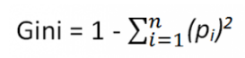

GI vs Entropy: https://quantdare.com/decision-trees-gini-vs-entropy/

Numeric Decision Tree
https://www.youtube.com/watch?v=5O8HvA9pMew
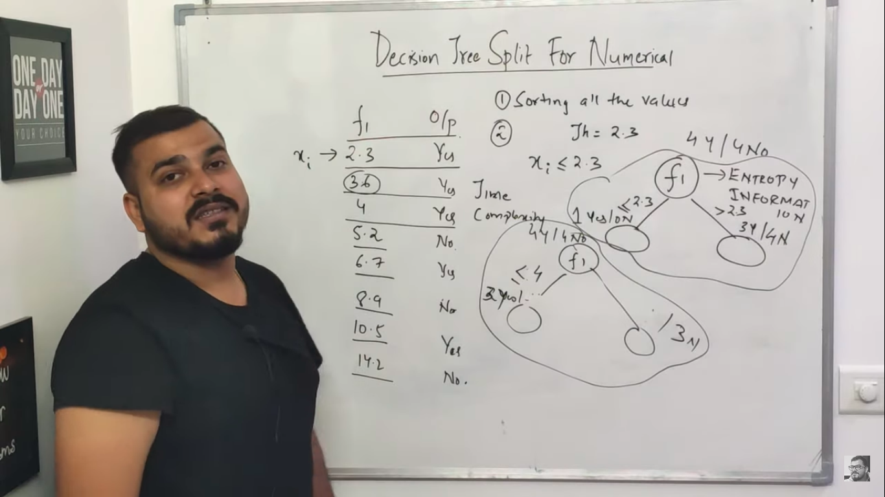

Clustering

K-means Clustering
https://towardsdatascience.com/k-means-clustering-from-a-to-z-f6242a314e9a
Check it in Scikit-Udemy.odt available in /home/vinoth/Learning/Python
1. Initialize K & Centroids - Intialize no.of cluster (e.g. : k=2). Choose random centroid(not necessarily from dataset)
2. Assigning Clusters to datapoints: Your model would calculate the distance(euclidean or manhattan) between the datapoint & all the centroids, and will be assigned to the cluster with the nearest centroid. We can also group datapoint in following techniques -- Draw straight line between centroids and then draw perpendicular line to the straight line connecting centroids. This perpendicular line group the data points to its centroids.
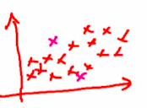
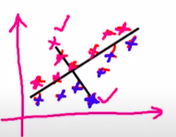

3. Updating Centroids: The new value might or might not occur in the dataset, in fact, it would be a coincidence if it does. This is because the updated cluster centorid is the average or the mean value of all the datapoints within that cluster. Now if some other algo, like K-Mode, or K-Median was used, instead of taking the average value, mode and median would be taken respectively.
4. Reassign each datapoint to new closest centroid until. If any assignment happens, repeat step 2 & 3 else finish it

Elbow Method: Choosing right number of clusters
WCSS – Within Cluster Sum of Square
Perform clustering by selecting different no. Of cluster(k value=1,2,3...) and calculate sum of square of distance between each datapoint and its centroid.

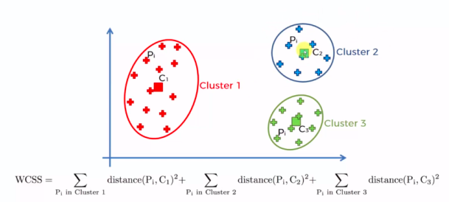
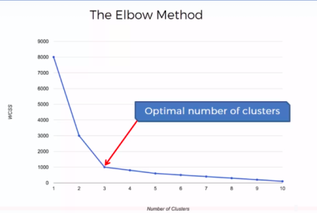

K-mean++
https://www.geeksforgeeks.org/ml-k-means-algorithm/
One disadvantage of the K-means algorithm is that it is sensitive to the initialization of the centroids or the mean points. To overcome the above-mentioned drawback we use K-means++. You pick a point randomly and that's your first centroid, then you pick the next point based on a probability that depends on the distance to the first point, the further apart the point is the more probable it is.

Hierarchial Clustering(HC)
https://www.analyticsvidhya.com/blog/2019/05/beginners-guide-hierarchical-clustering/
Check it in Scikit-Udemy.odt available in /home/vinoth/Learning/Python
In hierarchical clustering, we have a concept called a proximity matrix. This stores the distances between each point.

Agglomerative Hierarchical Clustering
- We assign each point to an individual cluster in this technique. Suppose there are 4 data points. We will assign each of these points to a cluster and hence will have 4 clusters in the beginning(Bottom-up approach)
- Then, at each iteration, we merge the closest pair of clusters and repeat this step until only a single cluster is left.

Divisive Hierarchical Clustering
- Divisive hierarchical clustering works in the opposite way. Instead of starting with n clusters (in case of n observations), we start with a single cluster and assign all the points to that cluster(Top-down approach)
- At each iteration, we split the farthest point in the cluster and repeat this process until each cluster only contains a single point.

Dendrogram: Choose the Number of Clusters
Euclidean distance between cluster is calculated and drawn in dendogram. X-axis is datapoints and Y-axis is Euclidean distance. Horizontal line is distance between clusters.
Each horizontal line(HL) is projected to y-axis(dotted line in below pic) and we should consider the vertical line that intercepts with projected HL. We need to choose interceptor such that it doesn’t cross projected HL.
Longest Vertical line that doesn’t crosses horizontal line.
The number of clusters will be the number of vertical lines which are being intersected by the line drawn using the threshold.
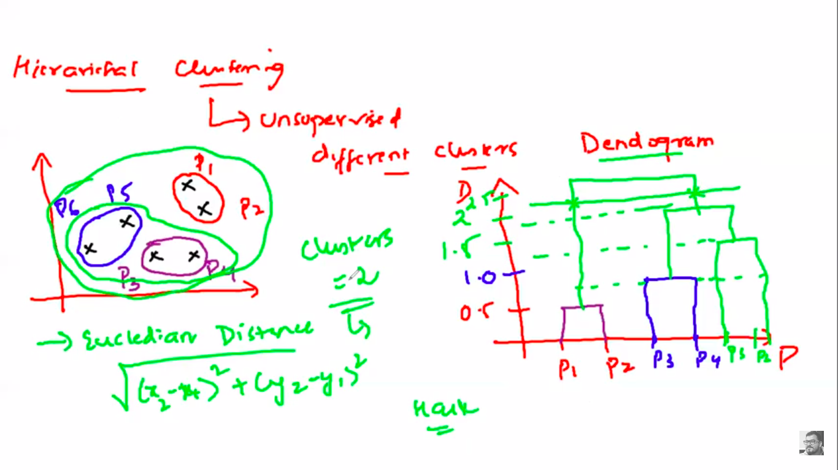

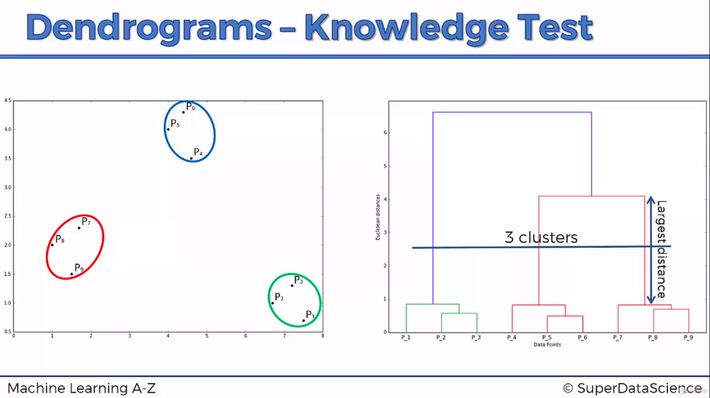
DBScan
Its available in ML_Common docs

Ensemble Technique
https://analyticsindiamag.com/primer-ensemble-learning-bagging-boosting

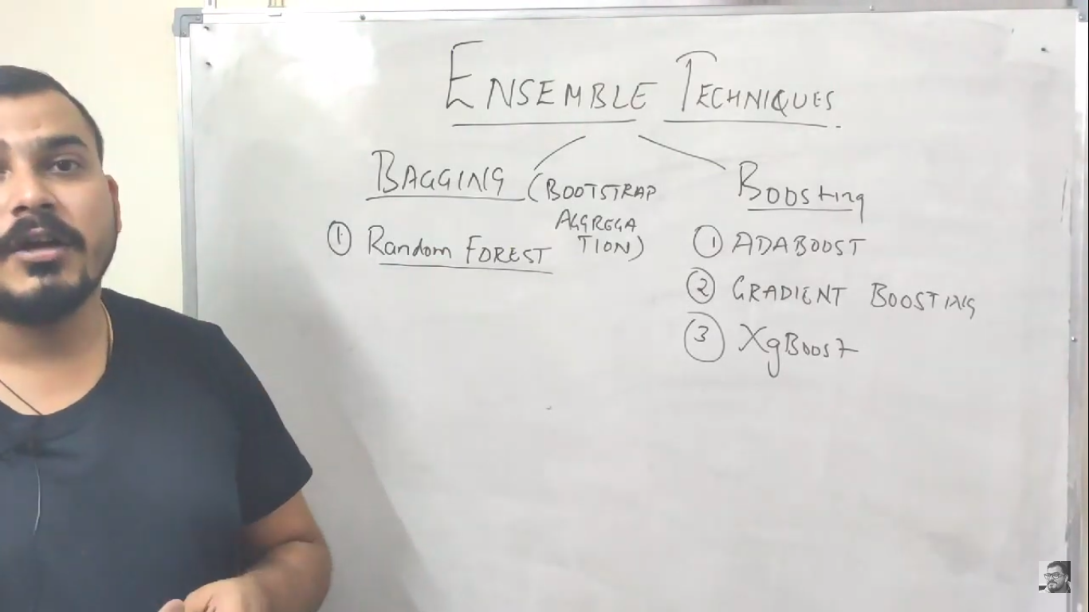
Bagging(Random Forest)
https://www.youtube.com/watch?v=nxFG5xdpDto&list=PLZoTAELRMXVPBTrWtJkn3wWQxZkmTXGwe&index=63
When the random forest is used, the algorithm makes n number of trees. It makes proper trees that consist of a start node with several leaves nodes. Some trees might be bigger than others, but there is no fixed depth in a random forest. Its called as Bootstrap aggregation.
RS-Row Sampling, FS-Feature Sampling, m-features, d-length, RF-Random Forest. Decision Tree(DT) provides low bias and high variance(overfitting). In RF, we are getting prediction from multiple DT, its result is combined and Majority votes is considered as final prediction which is low variance. There is a chance that same row will be shared by 2 or more DT.
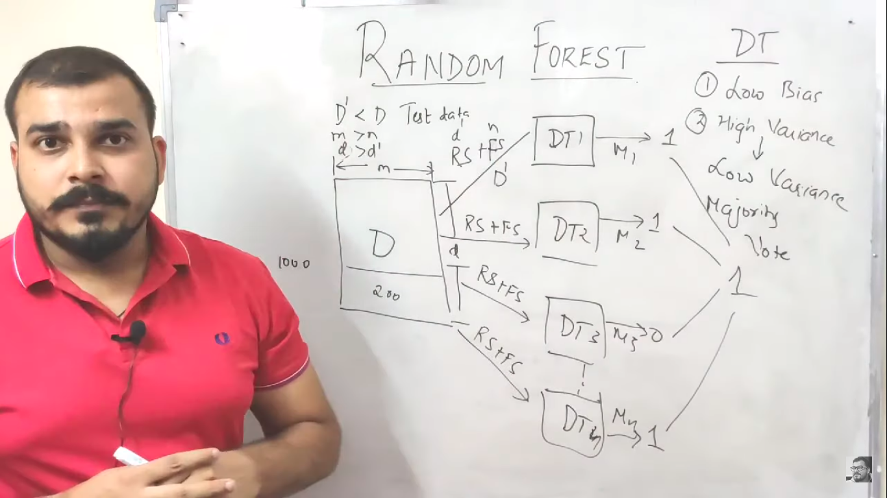
RF Regression will either calculate mean (or) medium from DT output and predict final result. In scikit learn, mean is used.
https://www.saedsayad.com/decision_tree_reg.htm

Boosting
D=Data, BL-Base Learner.
First data is passed to BL1. Incorrectly predicted data from BL1 will be passed to BL2 and goes on

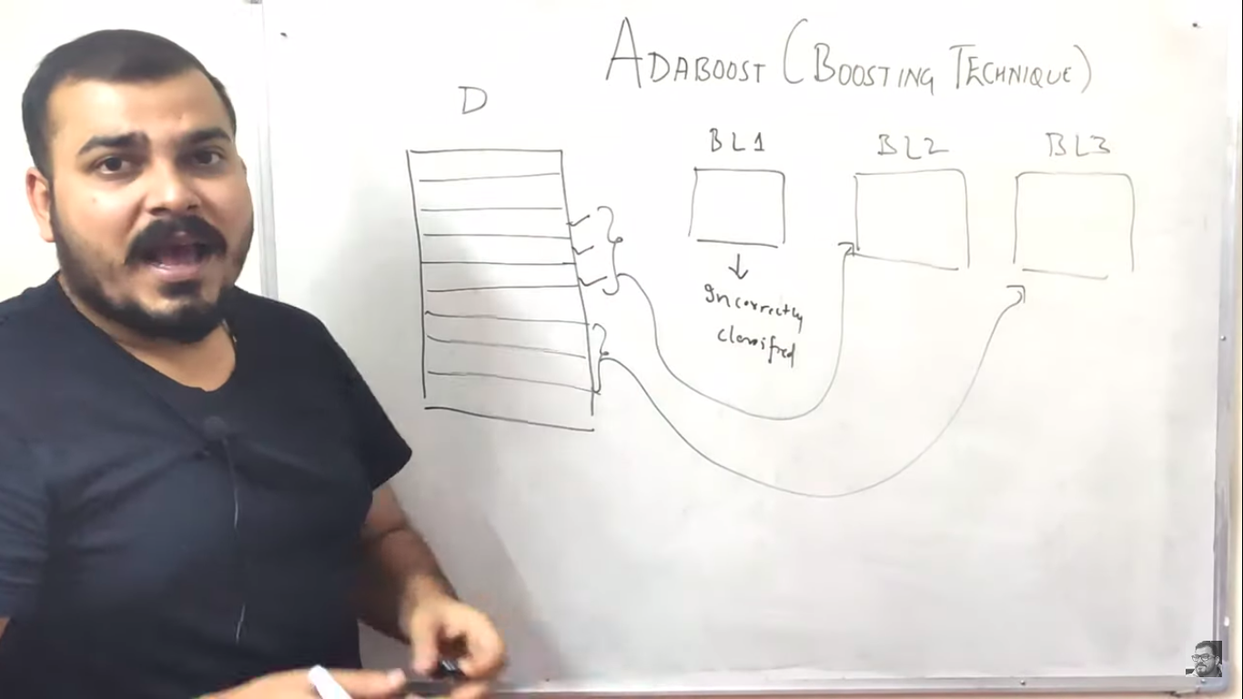
ADABOOST(Adaptive Boosting)
https://www.youtube.com/watch?v=NLRO1-jp5F8
https://www.mygreatlearning.com/blog/adaboost-algorithm/
https://machinelearningmastery.com/boosting-and-adaboost-for-machine-learning/
n=No of records.
Step 1: Create decision tree(DT) with each feature and calculate entropy or Gini index for each feature. One with least entropy is taken as Base Learner(BL). When the random forest is used, the algorithm makes n number of trees. It makes proper trees that consist of a start node with several leaves nodes. Some trees might be bigger than others, but there is no fixed depth in a random forest. But with Adaboost, that’s not the case. In AdaBoost, the algorithm only makes a node with two leaves, and this is known as Stump.Base node is called STUMPS. Calculate sample weight as W=1/N – N is the number of records
Step 2: After selecting DT with least entropy, calculate total error. In below example, 1(assume) is wrongly predicted, so 1/7. If many value is predicted incorrectly then sum of all wrongly predicted value.
Step 3: Calculate performance of stump using formula which helps in updating the sample weight with updated weight
Step 4: Calculate new sample weight using formula. For incorrect predict it will (e^perf) but for correct prediction its (e^-perf)
Step 5: Summation of all sample weight will be 1 but sum of updated weight isn’t 1. So normalizing it – (updated weight/sum of all updated weight)
Step 6: Creating New Dataset: After this the algorithm will run 5 iterations to select different-different records from the older dataset. Suppose, in 1st iteration, the algorithm will take a random value 0.46, then it will go and see in which bucket that value falls and selects that records in the new dataset, then again it will select a random value and see in which bucket it is and select that record for the new dataset and the same process is repeated for 5 times.There is a high probability for the wrong records to get selected several times. This will be the new dataset. New DT will select a bucket from previous DT and perform drom step 1. Refer above highlighted URL for more info.
Step 7: Atlast majority voting is selected as final prediction result
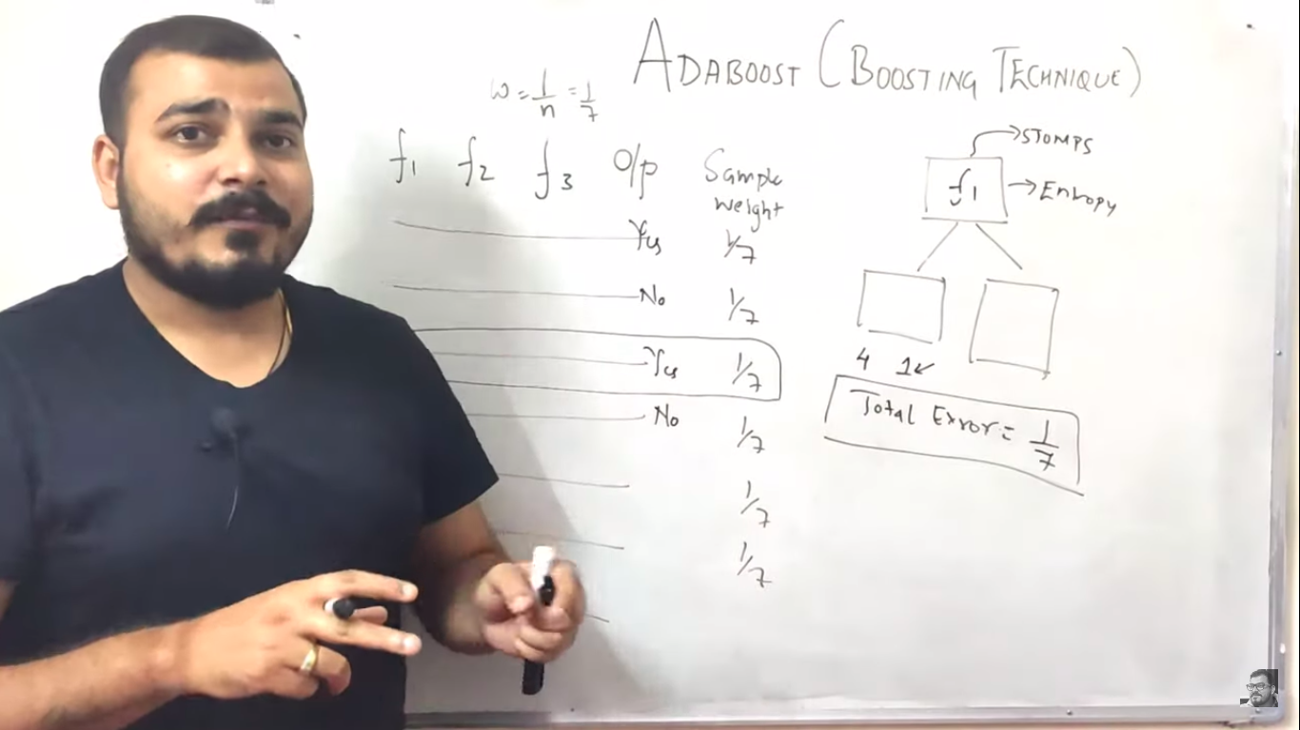


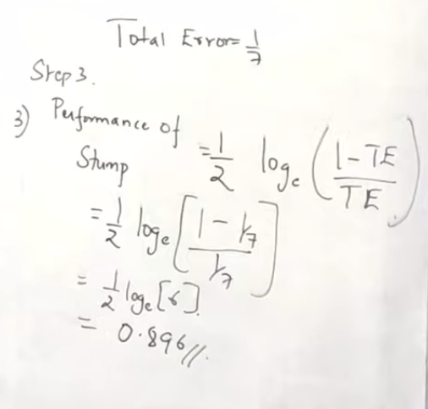
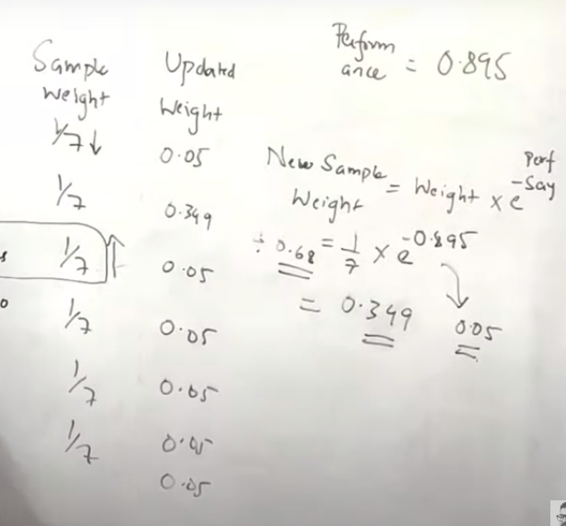

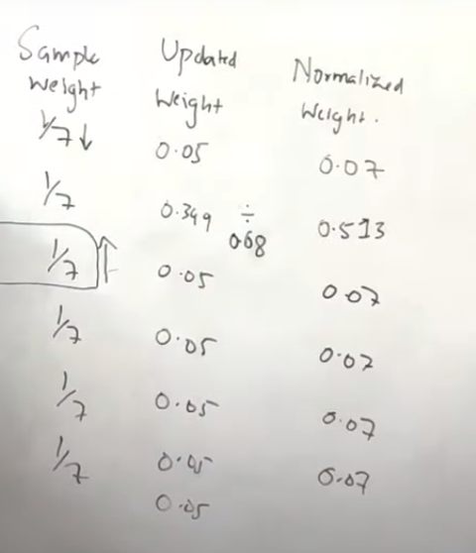
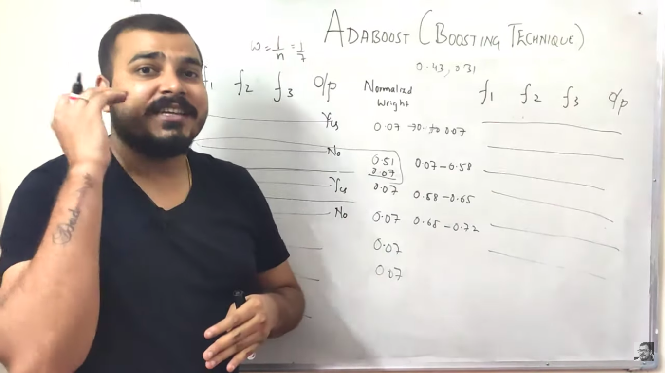


Gradient Boosting
Gradient descent mathematical calculation: https://www.mygreatlearning.com/blog/gradient-descent
Step 1: Base model calculates mean of all o/p value(salary) (y-hat)
Step 2: Compute residual error (actual-predicted)(R1)=salary-y^(Just for simplicity). We can use any cost (or) Loss funcction like MSE (or) MAE (or) R-Squared etc.
Step 3: Construct DT1 by passing independent variable(Xi - Exp, Degree) and Residual {Xi, R1}. R1 is dependent variable in this case. Predicted result will be R2
Step 4: 75-23(R2)=52. DT1 predicts 52 which is very close to actual result will result in over-fitting problem, so we multiple learning rate(0 to 1) to it. DT2 will get {Xi, R2} as input and compute residual error.
Step 5 :It can be generalized by Formula. Alpha is learning rate(0 to 1) which can be optimized using hyperparameter. Repeat steps 2 to 5 until it starts overfitting or the sum of residuals become constant. Overfitting can be controlled by consistently checking accuracy on validation data.
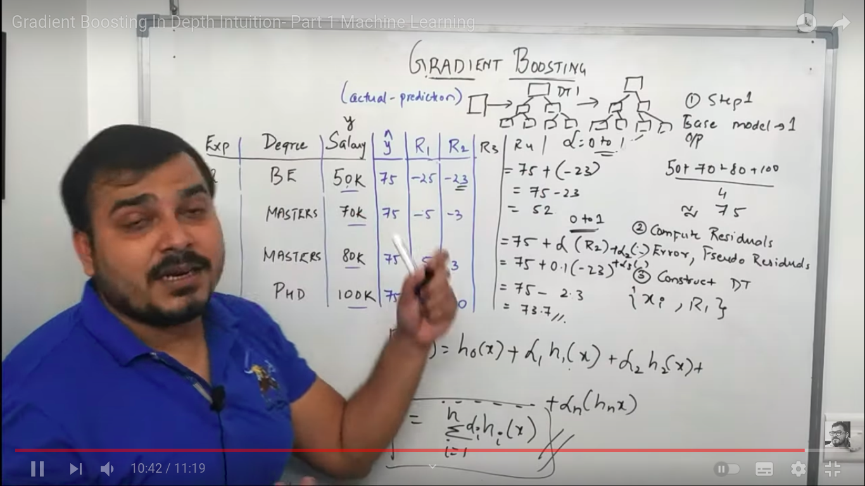
Step 1: We are doing first order derivative(FOD)(gradient descent) to find minimum loss function(gamma – which is y-hat). 1st find FOD for (50-yhat)^2=2*(50-yhat)^1 then FOD for (50-yhat)=0-1. FOD of constant is 0. Applying derivative chain rule, we find derivative of each term individually and add them up. Example for derivative chain rule is available in below link
https://www.math.ucdavis.edu/~kouba/CalcOneDIRECTORY/chainrulesoldirectory/ChainRuleSol.html#SOLUTION%203
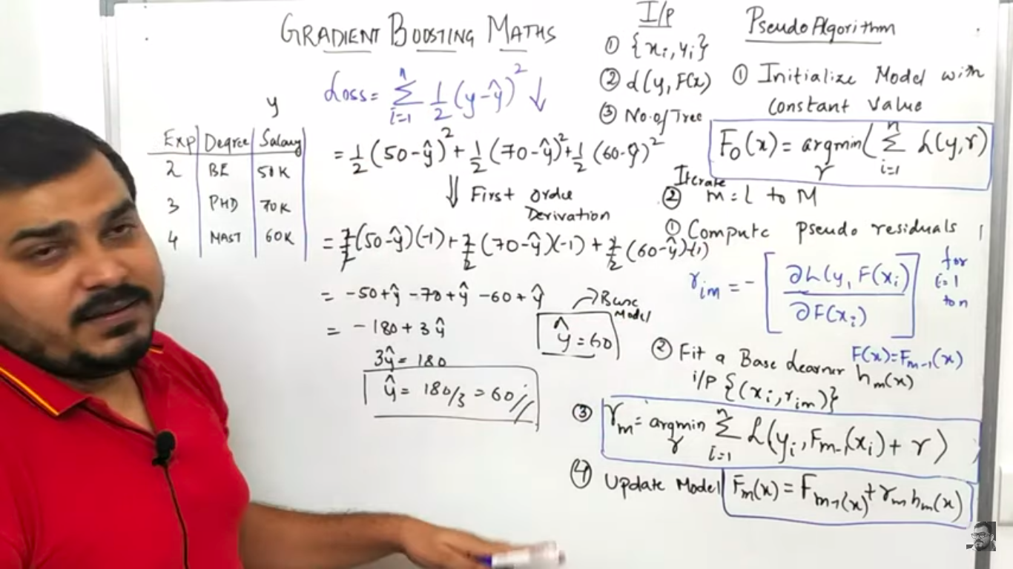
Step2: Iterate for m=1 to M nothing but number of tree.
Step 2.1: We update y-hat got from Step 1. F(xi) is derived in step 1. Calculate residual = y-y^ for each row which is -10,10,0 and for base learner(BL) Xi is independent variable and Residual will be dependent variable. Formula=Derivative of Loss w.r.t yi and F(xi)/derivate of F(Xi)
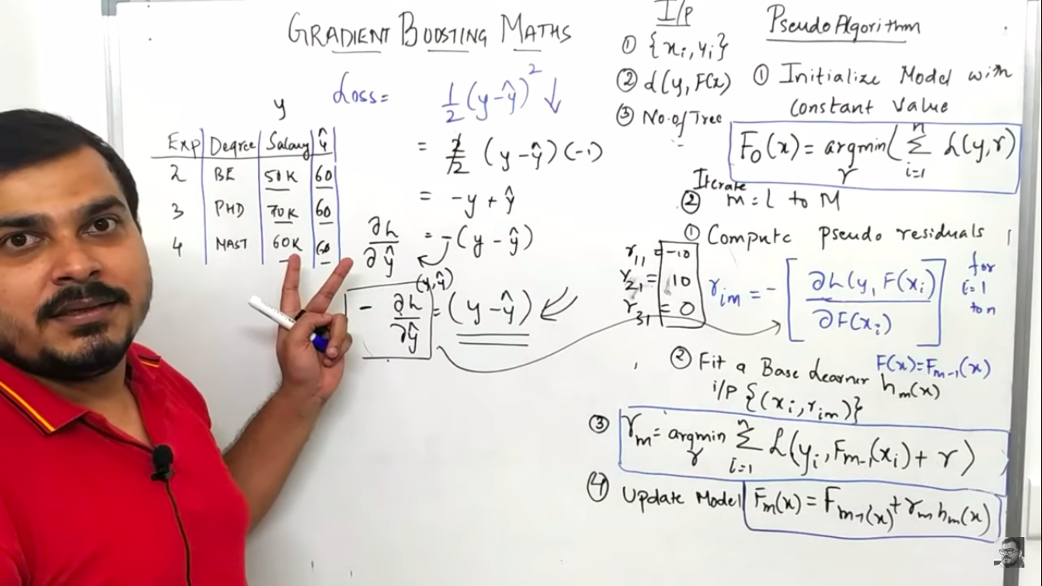
Step 2.2: Construct DT1 by passing independent variable(Xi - Exp, Degree) and Residual {Xi, Rim}. Rim is dependent variable in this case. Predicted result will be R2. Fm-1(Xi)-Previous result.
Step 2.3:
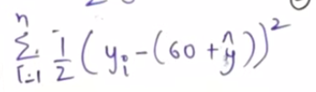

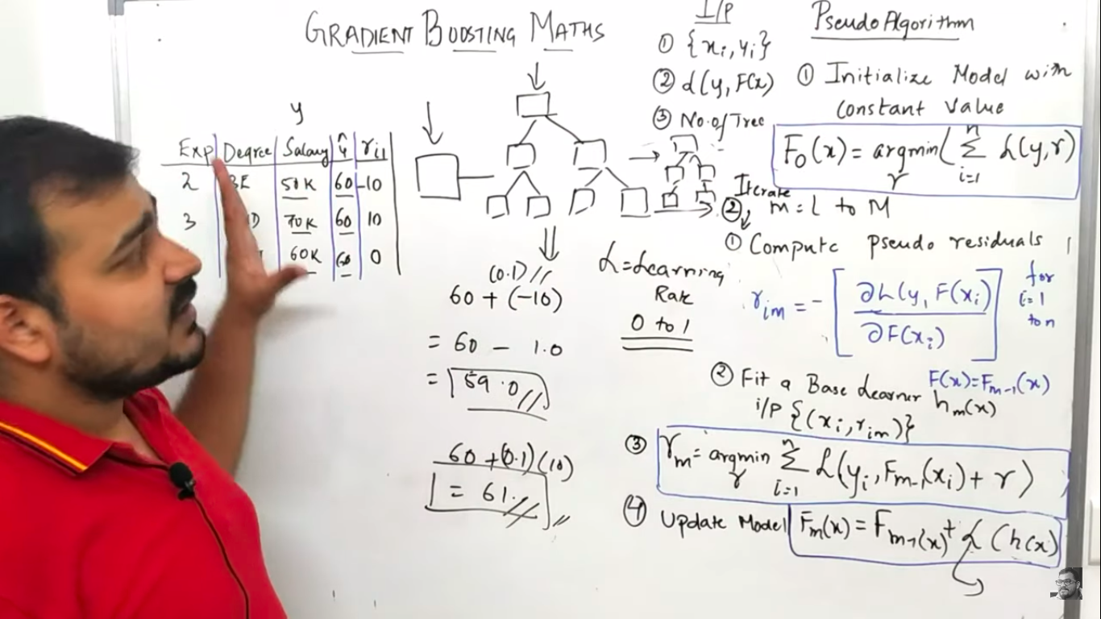
Step 2.4: Update the model using formula.Repeat these steps until it starts overfitting or the sum of residuals become very low.

XGBOOST(Extreme Gradient Boosting)
Probability(P) for binary classifier is 0+1/2=0.5. Residual(Res)=actual-P.
Step 1: XGBoost will create only binary DT(only 2 leaf node) irrespective of any number of categorial(Independent) variable. Calculate Residual(Res)=actual-P.
Step 2: Calculate similarity weight(SW) for each leaf node.SW for left leaf node is calculated below
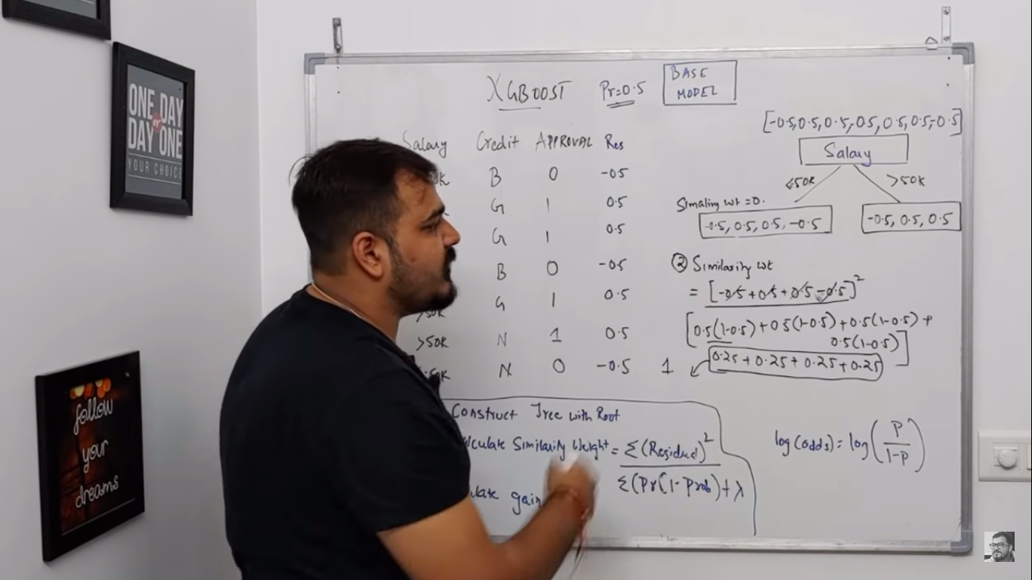
SW for Right leaf node & Root node(Salary). SW of root 7*0.25=1.75 --> 7 times 0.25 = 0.14. Pic1 – SW of right leaf & Pic2 – SW of root node.
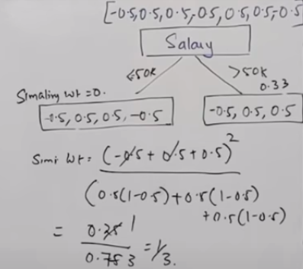
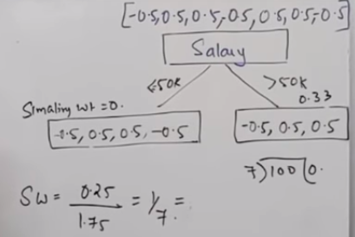

1st Pic: IG=sum of SW of leaf node-SW of base node. We will construct DT with each of the dependent variable and calculate IG(Information Gain). In below, binary DT is constructed with Salary. Similarly binary DT will also be created using credit(e.g: G, N&B) and determine IG. Choose binary DT with highest IG.
2nd Pic: Considering salary has high IG then other dependent variable. Then we need to predict how credit should be split since we have 3 values(B,N,G). We need to build binary DT for different combination. 2 different DT is created for Credit for salary <=50k. Both gives same IG, we can choose any. Here base node is 0.5,0.5,0.5,0.5.
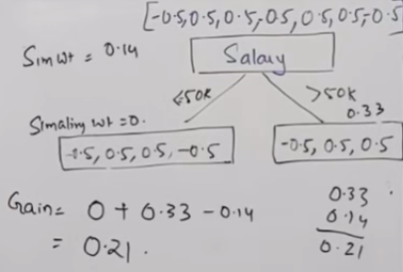
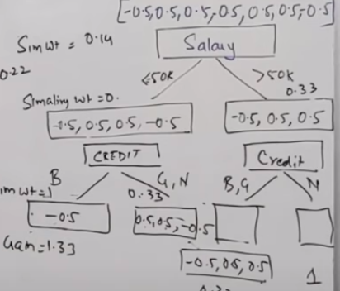

If new data comes(1st record), it will traverse tree to find its node position where it falls(Salary <=50 then credit as B where SW is 1). we need to find base model o/p with P=0.5. It can b done by log(odds). log(odds) for P=0.5 is 0, Base model gives o/p as 0. we apply sigmoid fn. Sigma(0+1*0.1(learning rate)), SW=1(traverse tree to find its position in node). Sigmoid fn at top right corner.
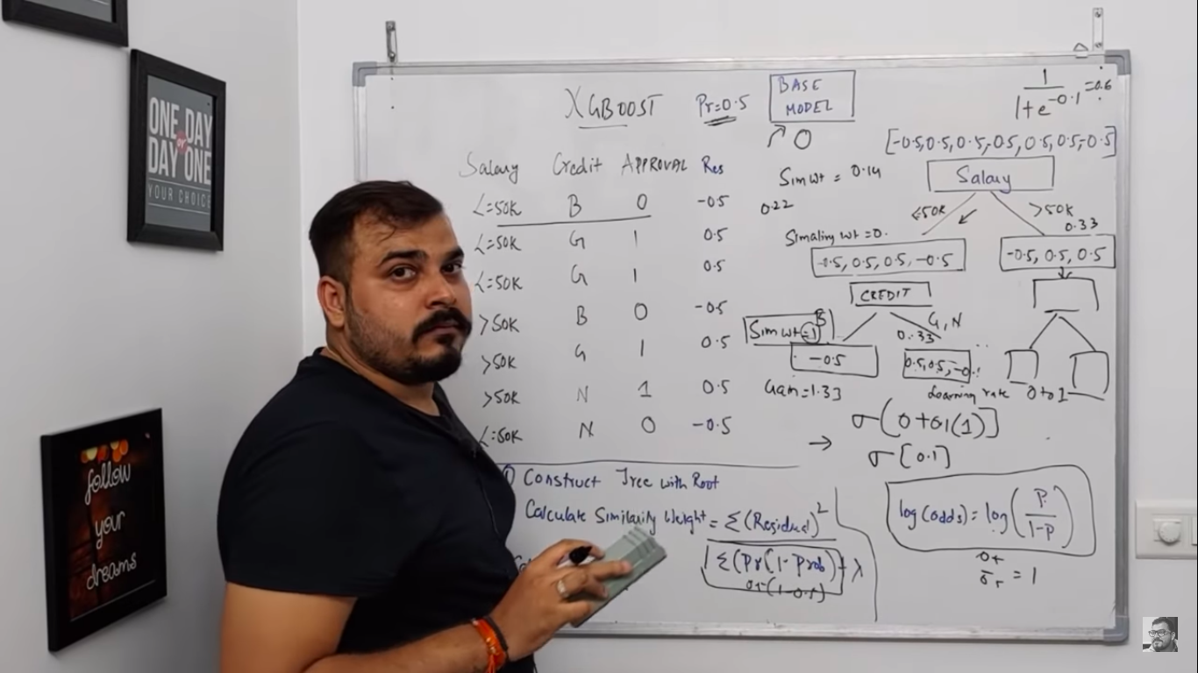
Calculate sigmoid fn for each row and it will be the new probability(NP). Residual(Res)=Approval-NP(1st row is wrong). This residual is used in next DT2. DT2 sigmoid is sum of BL & previous DT. Continue building DT and perfoem these steps until the residual is very very less.


XGBoost Regressor(XGR)
Similarity weight formula changes fr XGD = sum of square of residuals/No. Of res+lambda. Base Model is mean of salary=51k
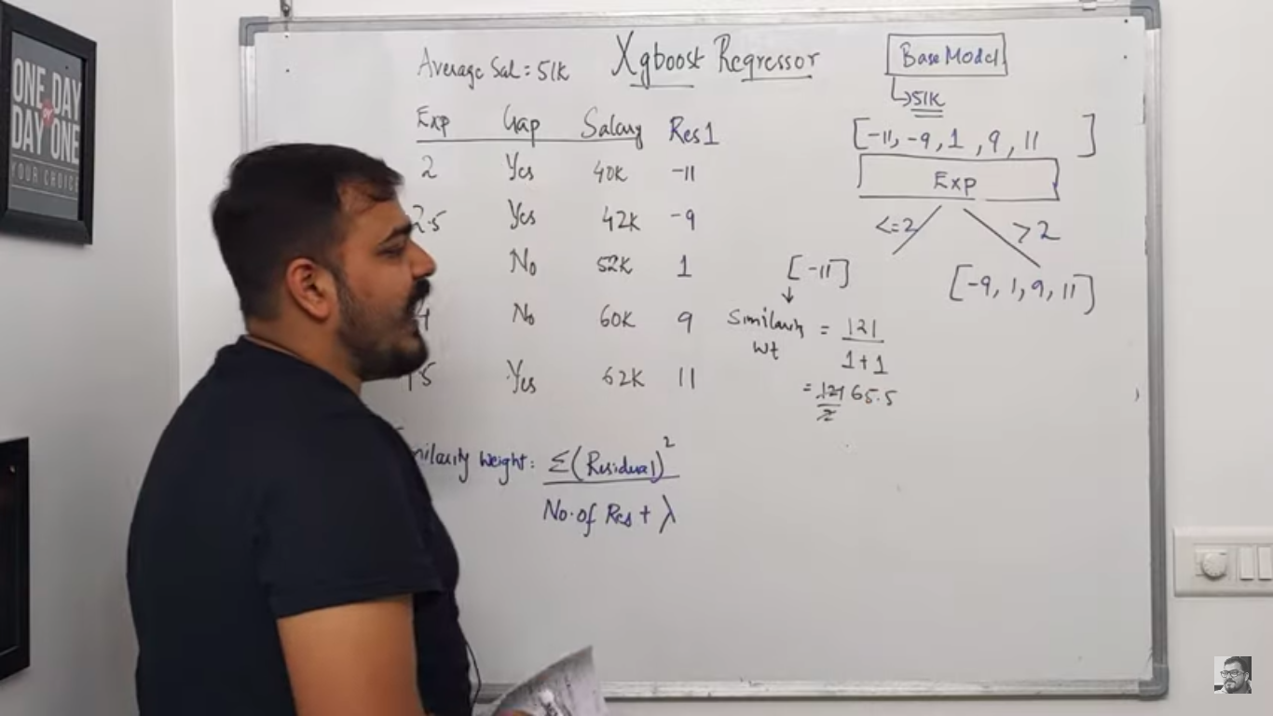
Fig 1: IG calculated for <=2 & >2=93.84(Sum of SW for leaf node-SW of root node)
Fig 2: IG calculated for <=2.5 & >2=143.42(Sum of SW for leaf node-SW of root node) greater than above one. So its optimal one. Wet have to split like this with rest of Exp to get more IG
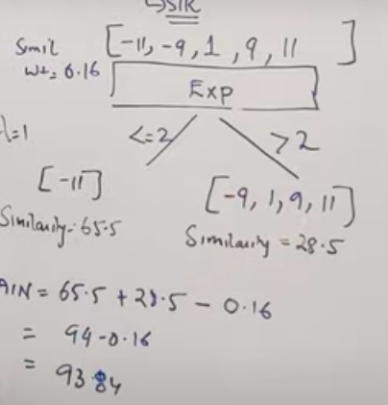
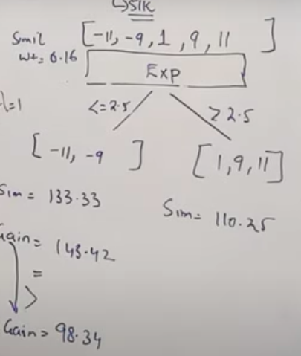

o/p is mean of node. Learning Rate=0.5. If 3rd row comes, it follows >2.5& No=>o/p=5. Residual 2 is calculated and its given as dependent variable to DT2 & dependent variable is Exp & Gap
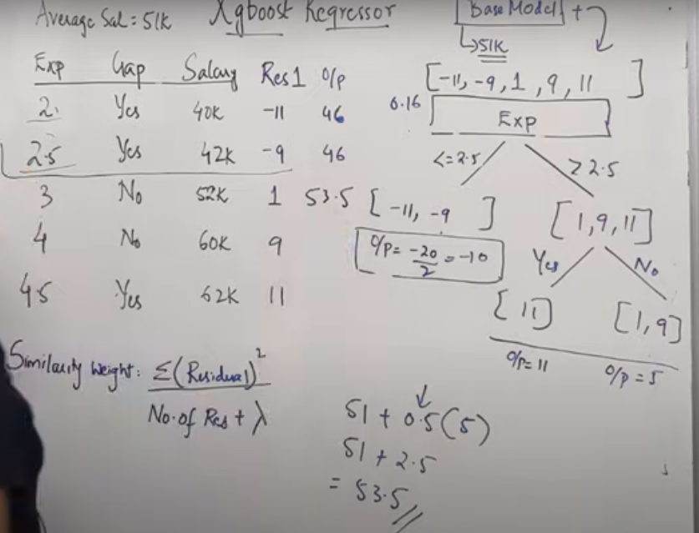
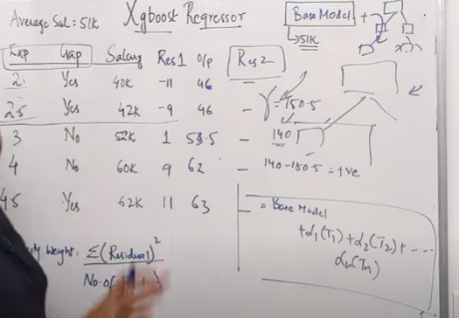

Reinforment Leaning
https://www.youtube.com/watch?v=vRcW5LDB7ng

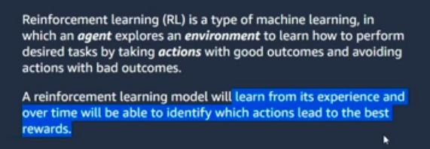
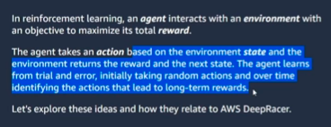


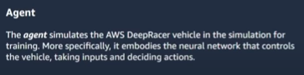

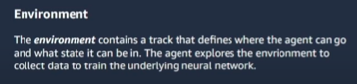

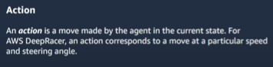

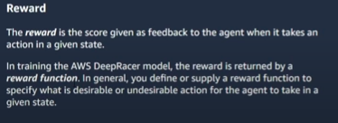

Metrics

Regression Metrics

R2_score vs MSE
https://vitalflux.com/mean-square-error-r-squared-which-one-to-use/
MSE - mean square error, RMSE – Root of MSE
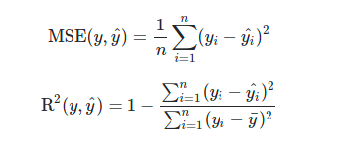

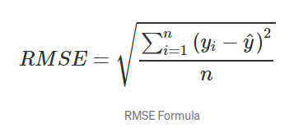

R-squared and Adjusted R-squared
https://www.analyticsvidhya.com/blog/2020/07/difference-between-r-squared-and-adjusted-r-squared/
Its available in ML_Common doc.

Classification Metrics
https://www.youtube.com/watch?v=aWAnNHXIKww
Refer Accuracy_Precision_Recall_F1.ipynb in /home/vinoth/Learning/Python/Workouts/ML-Udemy-Git
FP-Type 1 Error, FN-Type 2 Error. For balanced data set, we can use Accuracy metrics. For imbalanced data set, we need to use Precision (or) Recall.

Precision
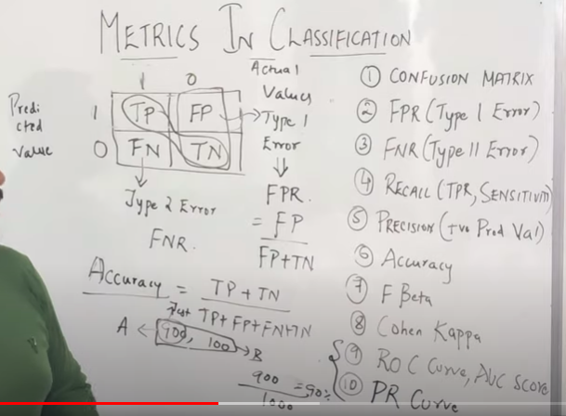
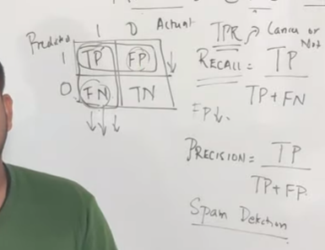
Ratio of number of correctly predicted value to total predicted value. We can use it in spam detection where FP needs to be reduced since important mail shouldn’t be classified as spam mail.
Whenever FP(False Positive) is important, we need to use Precision.

Recall
Ratio of number of correctly predicted value to actual value. We can use it to check if person have cancer (or) not, we need to reduce FN(person is having cancer but predicted as not). In this case if v have FP then atleast the person can take any test to confirm it.
Whenever FN(False Negative) is important, we need to use Recall.

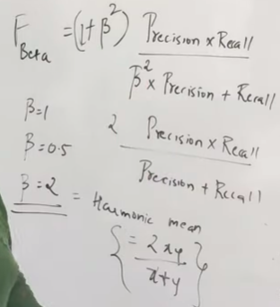
F-Beta Score
FP & FN both are important – Beta=1 then it refers to F1-Score
FP(Precision - Type 1 error) is important choose Beta=0.5(<1)
FN(Recall - Type 2 error) is important choose Beta=2(1 to 10)

ROC & AUC
https://www.analyticsvidhya.com/blog/2020/06/auc-roc-curve-machine-learning/
It is used in binary classification. It determines the probabilty threshold to segreagate the binary labels. In Logistic regression, if probability > 0.5, then it will be classified as 1 else 0. In many scenario, we need to set the threshold value inorder to get higher positive rate (or) less positive rate.

Common

Slope (or) Gradients (or) Derivative
https://www.mathsisfun.com/calculus/derivatives-introduction.html
Gradient descent mathematical calculation: https://www.mygreatlearning.com/blog/gradient-descent
Slope (or) gradients between 2 points:
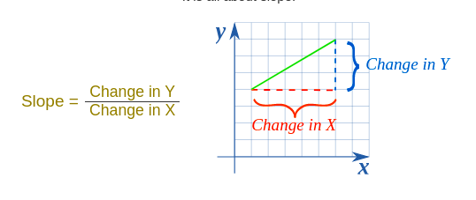

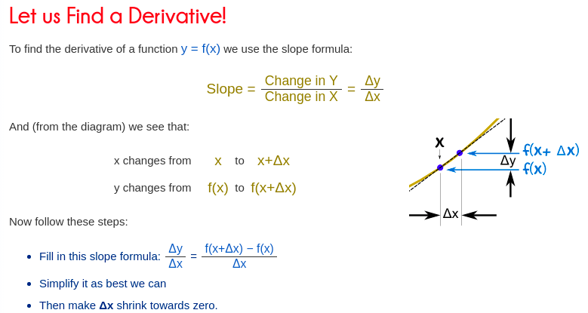
Slope (or) Gradient for single point: Dotted line is called tangent line

Gradient Descent
https://www.codeproject.com/Articles/1196024/Machine-Learning-Gradient-Descent

Derivative/differentiation
When updating the curve, to know in which direction and how much to change or update the curve depending upon the slope.That is why we use differentiation in almost every part of Machine Learning and Deep Learning.

First Order Derivates
The first order derivative mainly tells us that in which direction the function is going. That is whether the function is increasing or decreasing with respect to some given reference. The first order derivative also represents the instantaneous rate of change of some dependent variable with respect to an independent variable. In terms of the graph, it gives the slope of the tangent line drawn at a given point on the curve of the graph.

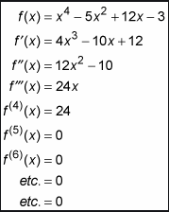
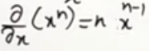

Variance & Standard Derivation(SD)
https://www.mathsisfun.com/data/standard-deviation.html
Variance is the average of the squared differences from the Mean.
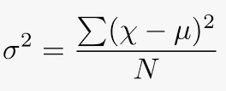

SD is the square root of the Variance
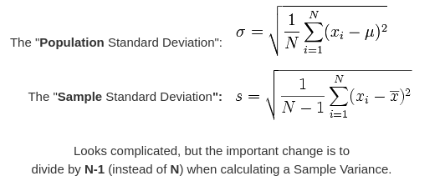

Feature Scaling
https://www.analyticsvidhya.com/blog/2020/04/feature-scaling-machine-learning-normalization-standardization/
https://machinelearningmastery.com/standardscaler-and-minmaxscaler-transforms-in-python/

Standardization
Standardization is another scaling technique where the values are centered around the mean with a unit standard deviation. This means that the mean of the attribute becomes zero and the resultant distribution has a unit(1) standard deviation.
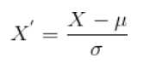

Normalization
Normalization is a scaling technique in which values are shifted and rescaled so that they end up ranging between 0 and 1. It is also known as Min-Max scaling.
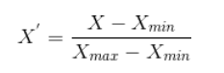

Distance

L1 (or) Snake (or) City block (or) Manhattan Distance
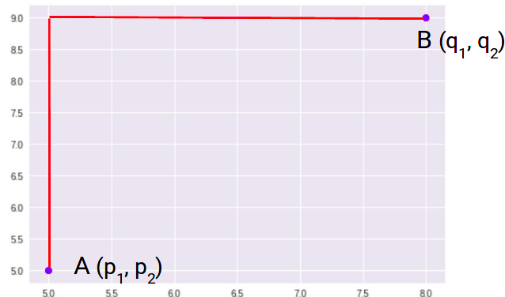
Manhattan Distance is the sum of absolute differences between points across all the dimensions.
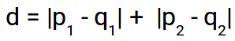
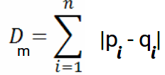

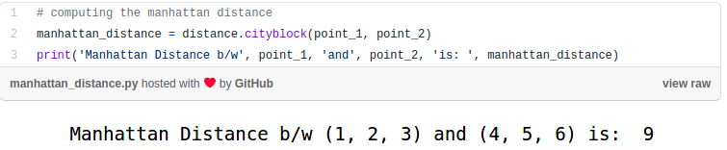

L2 (or) Euclidean distance
Euclidean Distance represents the shortest distance between two points.
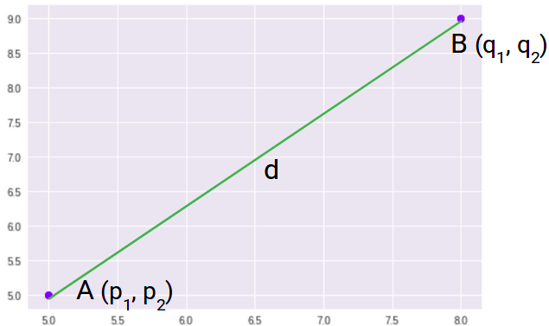
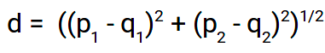
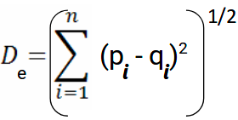

Hypothesis Test
H0 - null hypothesis. H1 – alterate hypothesis.

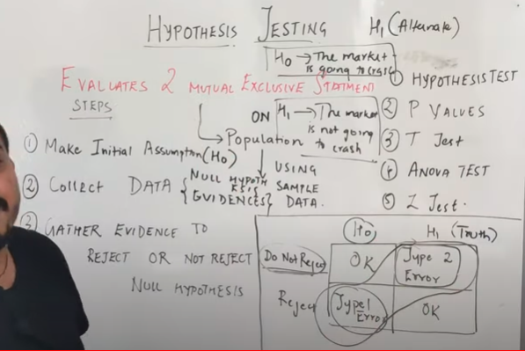
P Value,T test,Chi Square Test, Anova Test
If we consider 1 categorical feature then we need to use “One Sample Proportion Test”. If we have 2 categorical feature then we use “Chi Square Test”. 1 numeric feature – T Test. 2 numeric features – Correlation Test.

Loss (or) Cost Function
https://towardsdatascience.com/common-loss-functions-in-machine-learning-46af0ffc4d23
https://machinelearningknowledge.ai/cost-functions-in-machine-learning/
https://heartbeat.fritz.ai/5-regression-loss-functions-all-machine-learners-should-know-4fb140e9d4b0
I want to emphasize this here – although cost function and loss function are synonymous and used interchangeably, they are different.
A loss function is for a single training example. It is also sometimes called an error function. A cost function, on the other hand, is the average loss over the entire training dataset. The optimization strategies aim at minimizing the cost function.
If we have 10 record(row) of training set then loss function is calculated for each record. Cost function is average loss of all 10 records

Regression Loss function
Loss Function | Formula
Mean Square Error/Quadratic Loss/L2 Loss | 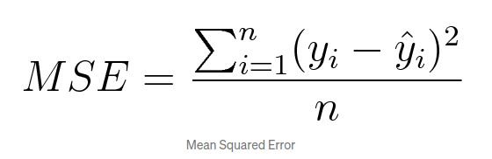
Mean Absolute Error/L1 Loss | 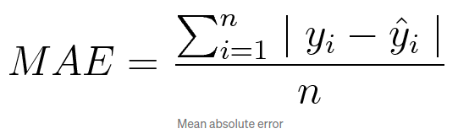
Mean Bias Error | 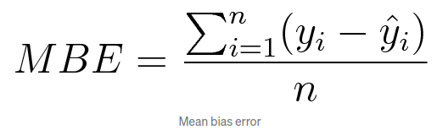

Classification Losses

Loss Function | Formula
Hinge Loss/Multi class SVM Loss | 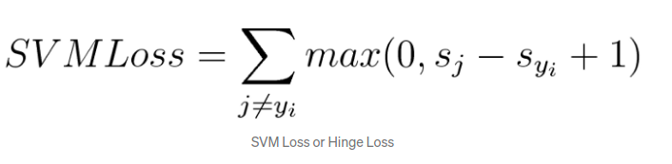
Cross Entropy Loss/Negative Log Likelihood | 

